UNITED STATES
SECURITIES AND EXCHANGE COMMISSION
Washington, D.C. 20549

FORM 8-K

CURRENT REPORT
Pursuant to Section 13 OR 15(d) of The Securities Exchange Act of 1934

Date of Report (Date of earliest event reported): November 12, 2024

DIME COMMUNITY BANCSHARES, INC.
(Exact name of registrant as specified in its charter)

New York |  | 001-34096 |  | 11-2934195
(State or other jurisdiction  of incorporation) |  | (Commission  File Number) |  | (IRS Employer  Identification No.)

898 Veterans Memorial Highway, Suite 560  Hauppauge, New York  (Address of principal executive offices) | 11788  (Zip Code)

631-537-1000
(Registrant’s telephone number, including area code)

Not Applicable
(Former name or former address, if changed since last report.)

Check the appropriate box below if the Form 8-K filing is intended to simultaneously satisfy the filing obligation of the registrant under any of the following provisions:
 | ☐ | Written communications pursuant to Rule 425 under the Securities Act (17 CFR 230.425)
 | ☐ | Soliciting material pursuant to Rule 14a-12 under the Exchange Act (17 CFR 240.14a-12)
 | ☐ | Pre-commencement communications pursuant to Rule 14d-2(b) under the Exchange Act (17 CFR 240.14d-2(b))
 | ☐ | Pre-commencement communications pursuant to Rule 13e-4(c) under the Exchange Act (17 CFR 240.13e-4(c))

Securities registered pursuant to Section 12(b) of the Act:

Title of each class: | Trading  Symbol(s): | Name of each exchange on which registered:
Common Stock, $0.01 Par Value | DCOM | NASDAQ
Preferred Stock, Series A, $0.01 Par Value | DCOMP | NASDAQ
9.000% Subordinated Notes, $25.00 Par Value | DCOMG | NASDAQ

Indicate by check mark whether the registrant is an emerging growth company as defined in Rule 405 of the Securities Act of 1933(§230.405 of this chapter) or Rule 12b-2 of the Securities Exchange Act of 1934 (§240.12b-2 of this chapter).

Emerging growth company ☐

If an emerging growth company, indicate by check mark if the registrant has elected not to use the extended transition period for complying with any new or revised financial accounting standards provided pursuant to Section 13(a) of the Exchange Act. ☐

Item 7.01 Regulation FD Disclosure

Dime Community Bancshares, Inc. (the “Company”) is hereby making available a presentation titled “Dime Follow-on Offering Investor Presentation” (the “Investor Presentation”), which is furnished as Exhibit 99.1 to this Current Report on Form 8-K.

The information in this Current Report on Form 8-K, including in Exhibit 99.1, is being furnished pursuant to Item 7.01 of Form 8-K and shall not be deemed “filed” for purposes of Section 18 of the Securities Exchange Act of 1934, as amended (the “Exchange Act”), or otherwise subject to the liabilities of that section, nor shall it be deemed incorporated by reference into any other filing under the Securities Act of 1933, as amended, or the Exchange Act.

Item 9.01 Financial Statements and Exhibits.

(d) Exhibits

Exhibit  No. |  | Description of Exhibit
99.1 |  | Investor Presentation titled, “Dime Follow-on Offering Investor Presentation”
104 |  | Cover Page Interactive Data File (embedded within the Inline XBRL document)

SIGNATURE

Pursuant to the requirements of the Securities Exchange Act of 1934, the registrant has duly caused this report to be signed on its behalf by the undersigned hereunto duly authorized.

Date: November 12, 2024 | DIME COMMUNITY BANCSHARES, INC.
 | By: | /s/ Judy Wu
Judy Wu
Executive Vice President & General Counsel

Exhibit 99.1

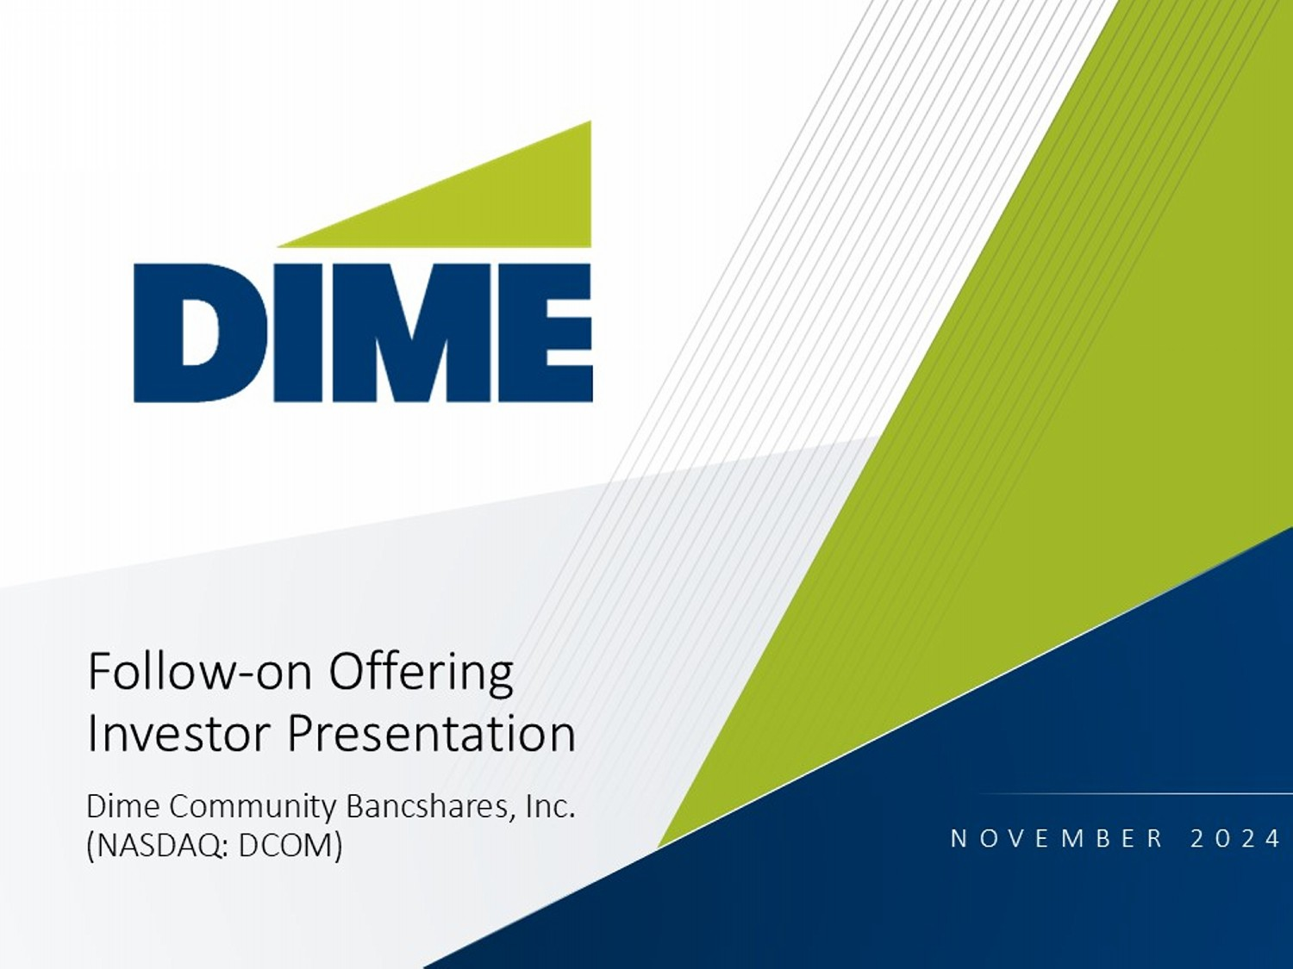
1 Follow - on Offering Investor Presentation Dime Community Bancshares, Inc. (NASDAQ: DCOM) NOVEMBER 2024
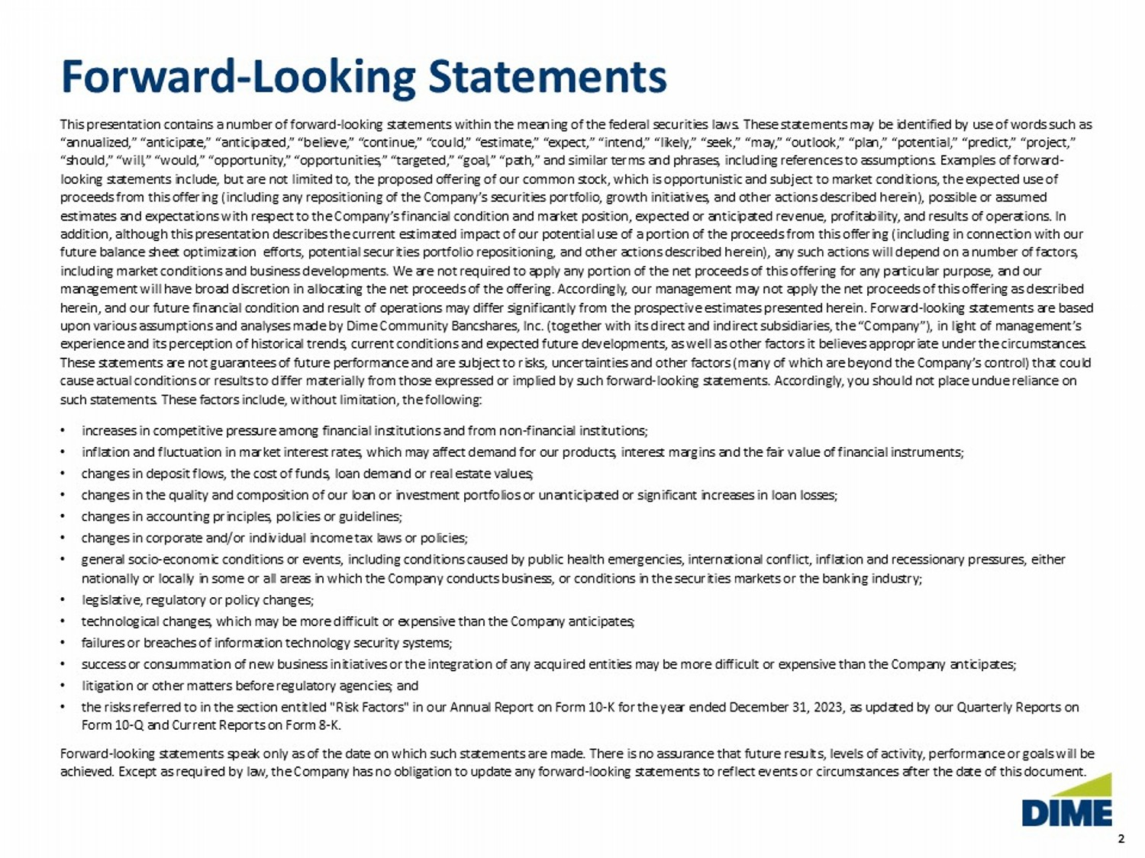
2 2 Forward - Looking Statements This presentation contains a number of forward - looking statements within the meaning of the federal securities laws. These state ments may be identified by use of words such as “annualized,” “anticipate,” “anticipated,” “believe,” “continue,” “could,” “estimate,” “expect,” “intend,” “likely,” “seek,” “ma y,” “outlook,” “plan,” “potential,” “predict,” “project,” “should,” “will,” “would,” “opportunity,” “opportunities,” “targeted,” “goal,” “path,” and similar terms and phrases, includi ng references to assumptions. Examples of forward - looking statements include, but are not limited to, the proposed offering of our common stock, which is opportunistic and sub jec t to market conditions, the expected use of proceeds from this offering (including any repositioning of the Company’s securities portfolio, growth initiatives, and other ac tions described herein), possible or assumed estimates and expectations with respect to the Company’s financial condition and market position, expected or anticipated rev enu e, profitability, and results of operations. In addition, although this presentation describes the current estimated impact of our potential use of a portion of the proceeds fr om this offering (including in connection with our future balance sheet optimization efforts, potential securities portfolio repositioning, and other actions described herein) , a ny such actions will depend on a number of factors, including market conditions and business developments. We are not required to apply any portion of the net proceeds of this o ffe ring for any particular purpose, and our management will have broad discretion in allocating the net proceeds of the offering. Accordingly, our management may not app ly the net proceeds of this offering as described herein, and our future financial condition and result of operations may differ significantly from the prospective estimates p res ented herein. Forward - looking statements are based upon various assumptions and analyses made by Dime Community Bancshares, Inc. (together with its direct and indirect subsidia rie s, the “Company”), in light of management’s experience and its perception of historical trends, current conditions and expected future developments, as well as other fac tor s it believes appropriate under the circumstances. These statements are not guarantees of future performance and are subject to risks, uncertainties and other factors (many of whi ch are beyond the Company’s control) that could cause actual conditions or results to differ materially from those expressed or implied by such forward - looking statements. Acco rdingly, you should not place undue reliance on such statements. These factors include, without limitation, the following: • increases in competitive pressure among financial institutions and from non - financial institutions; • inflation and fluctuation in market interest rates, which may affect demand for our products, interest margins and the fair v alu e of financial instruments; • changes in deposit flows, the cost of funds, loan demand or real estate values; • changes in the quality and composition of our loan or investment portfolios or unanticipated or significant increases in loan lo sses; • changes in accounting principles, policies or guidelines; • changes in corporate and/or individual income tax laws or policies; • general socio - economic conditions or events, including conditions caused by public health emergencies, international conflict, i nflation and recessionary pressures, either nationally or locally in some or all areas in which the Company conducts business, or conditions in the securities markets or th e banking industry; • legislative, regulatory or policy changes; • technological changes, which may be more difficult or expensive than the Company anticipates; • failures or breaches of information technology security systems; • success or consummation of new business initiatives or the integration of any acquired entities may be more difficult or expe nsi ve than the Company anticipates; • litigation or other matters before regulatory agencies; and • the risks referred to in the section entitled "Risk Factors" in our Annual Report on Form 10 - K for the year ended December 31, 2 023, as updated by our Quarterly Reports on Form 10 - Q and Current Reports on Form 8 - K. Forward - looking statements speak only as of the date on which such statements are made. There is no assurance that future result s, levels of activity, performance or goals will be achieved. Except as required by law, the Company has no obligation to update any forward - looking statements to reflect events or circumstances after the date of this document.
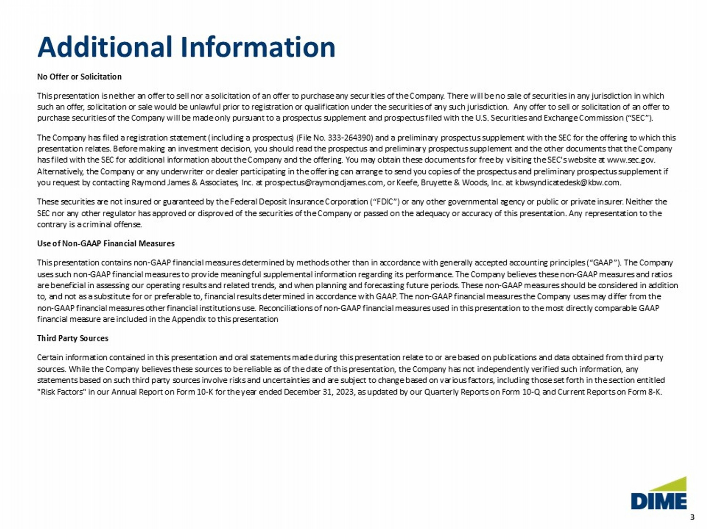
3 3 Additional Information No Offer or Solicitation This presentation is neither an offer to sell nor a solicitation of an offer to purchase any securities of the Company. There wi ll be no sale of securities in any jurisdiction in which such an offer, solicitation or sale would be unlawful prior to registration or qualification under the securities of any such ju risdiction. Any offer to sell or solicitation of an offer to purchase securities of the Company will be made only pursuant to a prospectus supplement and prospectus filed with the U.S. S ecu rities and Exchange Commission (“SEC”). The Company has filed a registration statement (including a prospectus) (File No. 333 - 264390) and a preliminary prospectus suppl ement with the SEC for the offering to which this presentation relates. Before making an investment decision, you should read the prospectus and preliminary prospectus supplem ent and the other documents that the Company has filed with the SEC for additional information about the Company and the offering. You may obtain these documents for free by visiting the SEC's website at www.sec.gov. Alternatively, the Company or any underwriter or dealer participating in the offering can arrange to send you copies of the p ros pectus and preliminary prospectus supplement if you request by contacting Raymond James & Associates, Inc. at prospectus@raymondjames.com, or Keefe, Bruyette & Woods, Inc. a t kbwsyndicatedesk @kbw.com. These securities are not insured or guaranteed by the Federal Deposit Insurance Corporation (“FDIC”) or any other governmenta l a gency or public or private insurer. Neither the SEC nor any other regulator has approved or disproved of the securities of the Company or passed on the adequacy or accuracy of this presentation. Any representation to the contrary is a criminal offense. Use of Non - GAAP Financial Measures This presentation contains non - GAAP financial measures determined by methods other than in accordance with generally accepted ac counting principles (“GAAP”). The Company uses such non - GAAP financial measures to provide meaningful supplemental information regarding its performance. The Company beli eves these non - GAAP measures and ratios are beneficial in assessing our operating results and related trends, and when planning and forecasting future periods. These no n - GAAP measures should be considered in addition to, and not as a substitute for or preferable to, financial results determined in accordance with GAAP. The non - GAAP financial m easures the Company uses may differ from the non - GAAP financial measures other financial institutions use. Reconciliations of non - GAAP financial measures used in this presen tation to the most directly comparable GAAP financial measure are included in the Appendix to this presentation Third Party Sources Certain information contained in this presentation and oral statements made during this presentation relate to or are based o n p ublications and data obtained from third party sources. While the Company believes these sources to be reliable as of the date of this presentation, the Company has not ind epe ndently verified such information, any statements based on such third party sources involve risks and uncertainties and are subject to change based on various facto rs, including those set forth in the section entitled "Risk Factors" in our Annual Report on Form 10 - K for the year ended December 31, 2023, as updated by our Quarterly Reports on Fo rm 10 - Q and Current Reports on Form 8 - K.
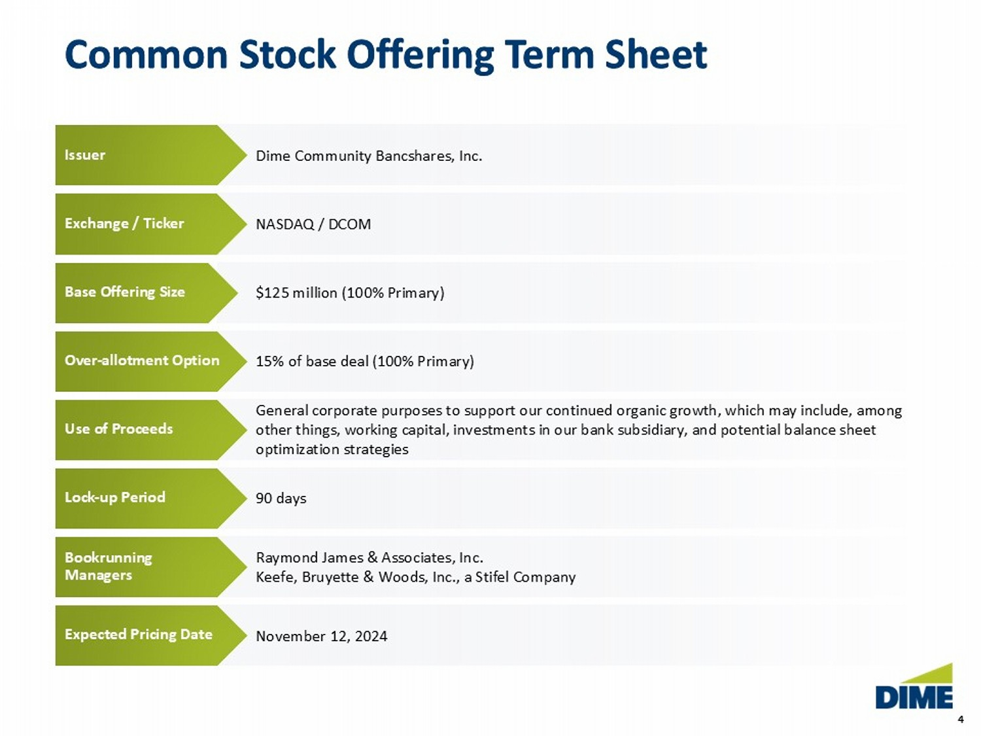
4 4 Common Stock Offering Term Sheet November 12 , 2024 Raymond James & Associates, Inc. Keefe, Bruyette & Woods, Inc., a Stifel Company 90 days General corporate purposes to support our continued organic growth, which may include, among other things, working capital, investments in our bank subsidiary, and potential balance sheet optimization strategies 15% of base deal (100% Primary) $125 million (100% Primary) Dime Community Bancshares, Inc. NASDAQ / DCOM Issuer Exchange / Ticker Base O ffering S ize Over - allotment Option Use of Proceeds Lock - up Period Bookrunning Managers Expected Pricing Date Common Stock Offering Term Sheet
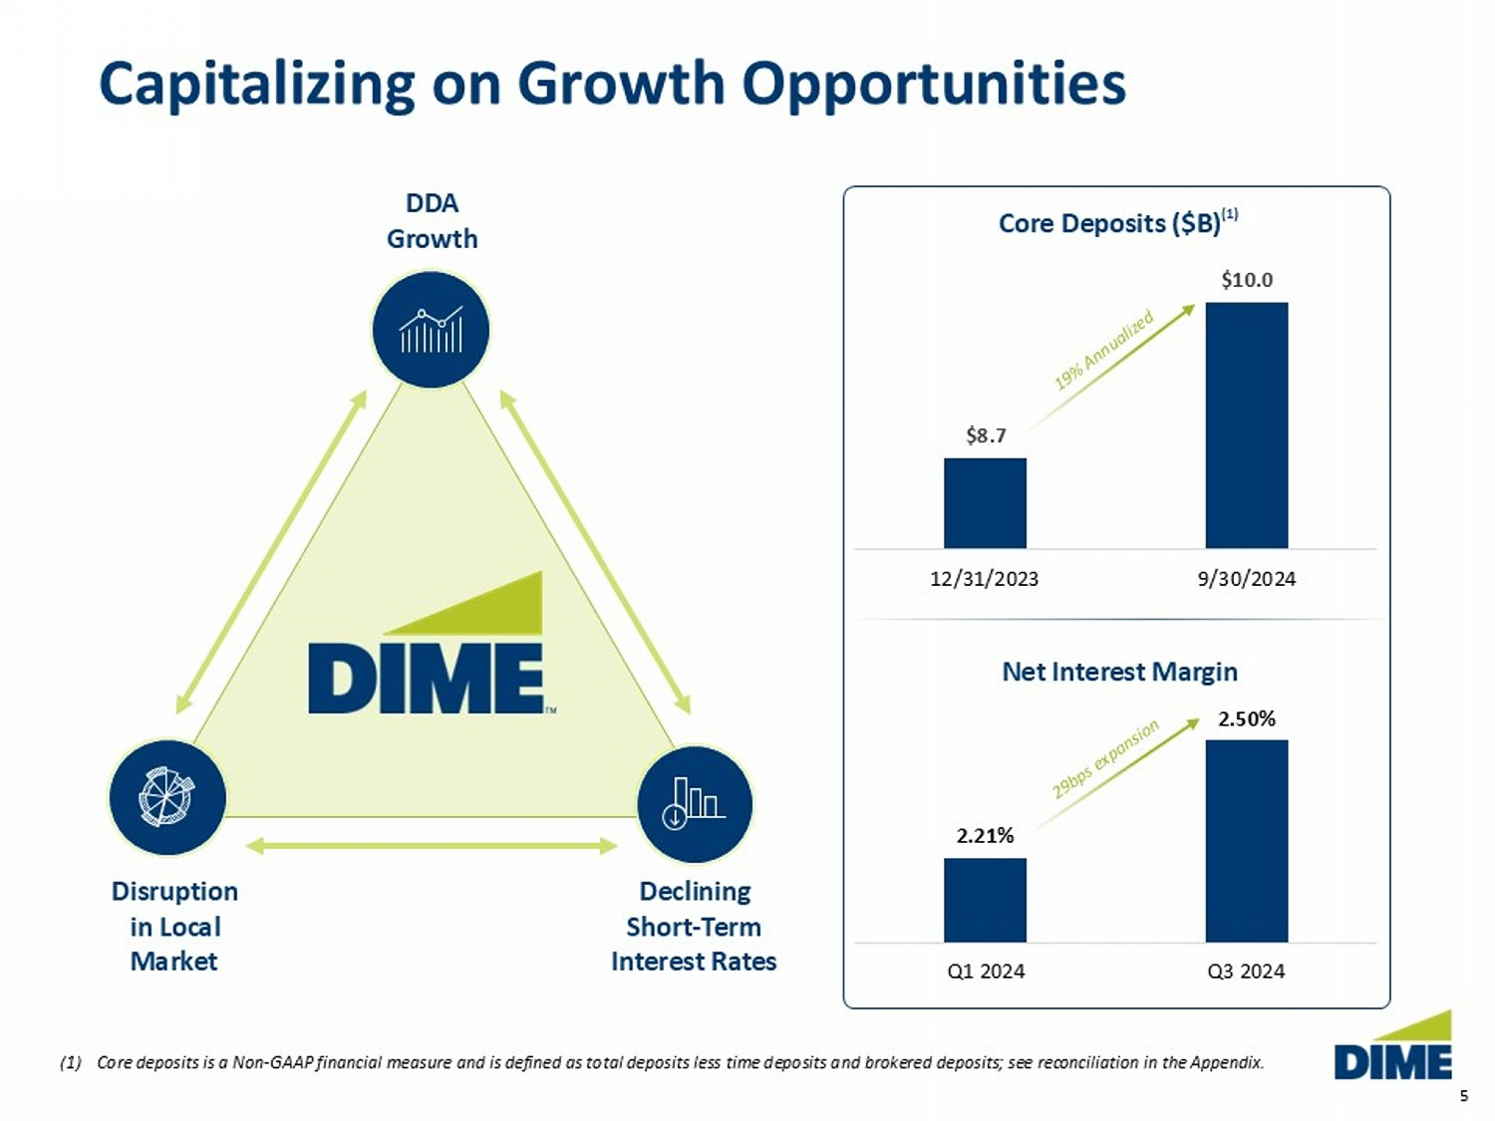
5 Capitalizing on Growth Opportunities (1) Core deposits is a Non - GAAP financial measure and is defined as total deposits less time deposits and brokered deposits; see rec onciliation in the Appendix. $8.7 $10.0 12/31/2023 9/30/2024 DDA Growth Declining Short - Term Interest Rates Disruption in Local Market Core Deposits ($B) (1) 2.21% 2.50% Q1 2024 Q3 2024 Net Interest Margin
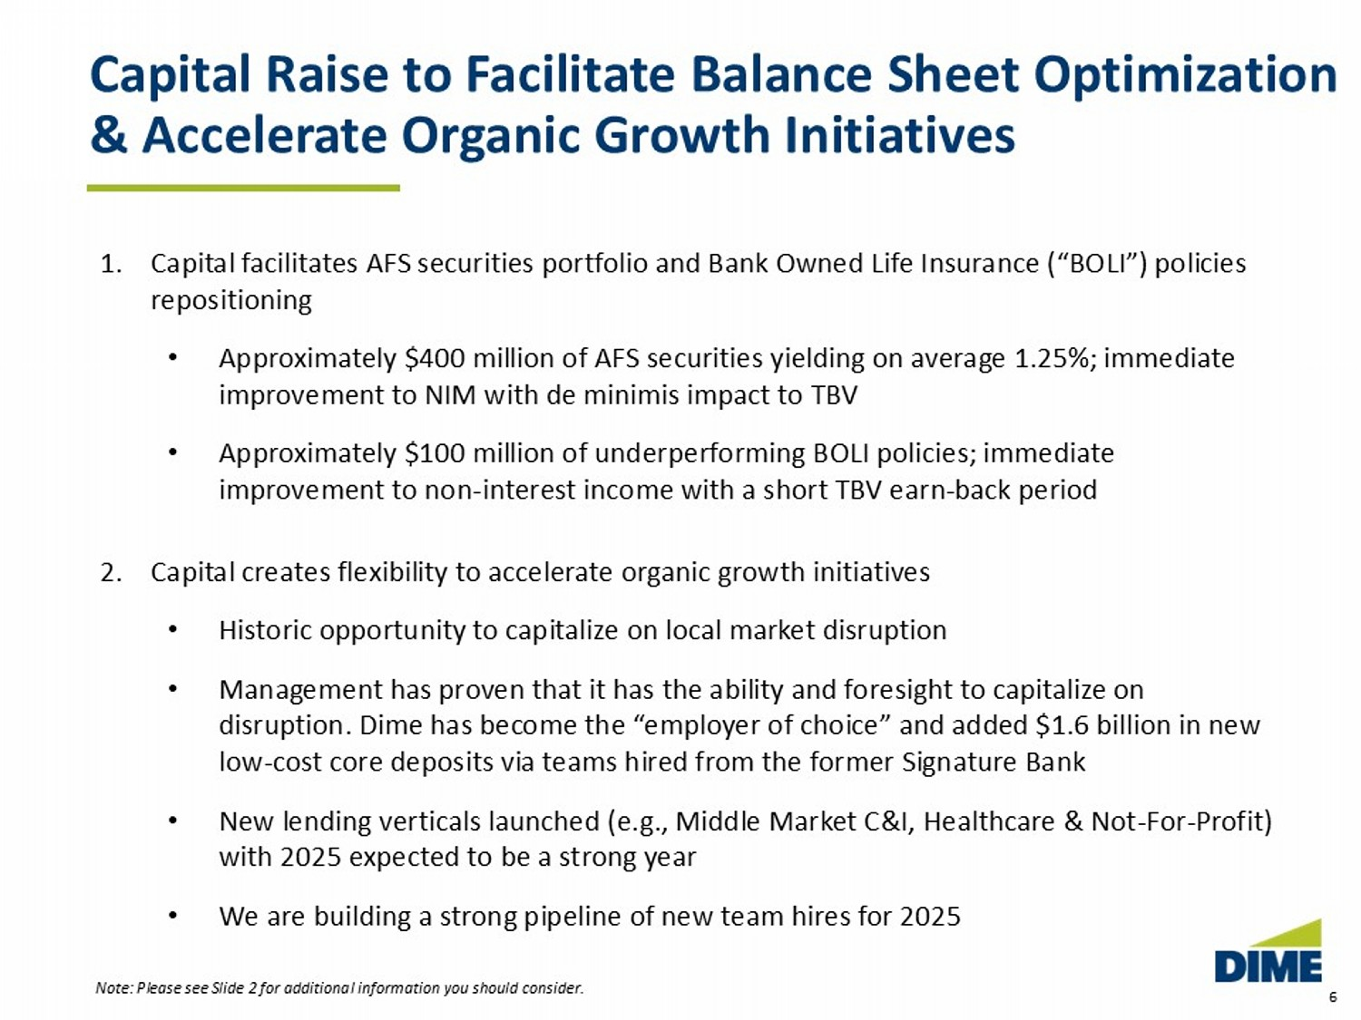
6 1. Capital facilitates AFS securities portfolio and Bank Owned Life Insurance (“BOLI”) policies repositioning • Approximately $400 million of AFS securities yielding on average 1.25%; immediate improvement to NIM with de minimis impact to TBV • Approximately $100 million of underperforming BOLI policies; immediate improvement to non - interest income with a short TBV earn - back period 2. Capital creates flexibility to accelerate organic growth initiatives • Historic opportunity to capitalize on local market disruption • Management has proven that it has the ability and foresight to capitalize on disruption. Dime has become the “employer of choice” and added $1.6 billion in new low - cost core deposits via teams hired from the former Signature Bank • New lending verticals launched (e.g., Middle Market C&I, Healthcare & Not - For - Profit) with 2025 expected to be a strong year • We are building a strong pipeline of new team hires for 2025 Capital Raise to Facilitate Balance Sheet Optimization & Accelerate Organic Growth Initiatives Note: Please see Slide 2 for additional information you should consider.
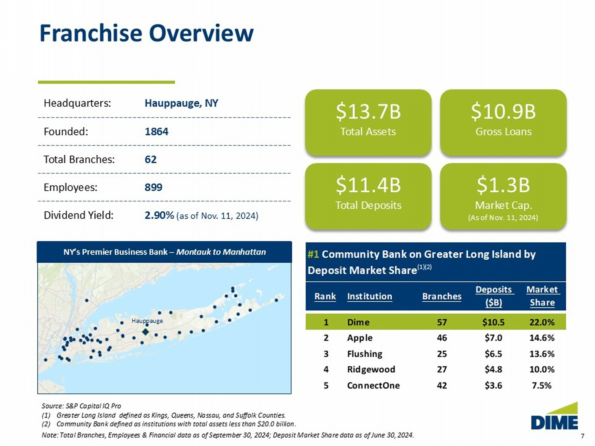
7 Hauppauge Rank Institution Branches Deposits ($B) Market Share 1 Dime 57 $10.5 22.0% 2 Apple 46 $7.0 14.6% 3 Flushing 25 $6.5 13.6% 4 Ridgewood 27 $4.8 10.0% 5 ConnectOne 42 $3.6 7.5% #1 Community Bank on Greater Long Island by Deposit Market Share Franchise Overview NY’s Premier Business Bank – Montauk to Manhattan $11.4B Total Deposits $13.7B Total Assets $10.9B Gross Loans $1.3B Market Cap. (As of Nov. 11, 2024) Hauppauge, NY Headquarters: 1864 Founded: 62 Total Branches: 899 Employees: 2.90% (as of Nov. 11, 2024) Dividend Yield: Source: S&P Capital IQ Pro (1) Greater Long Island defined as Kings, Queens, Nassau, and Suffolk Counties. (2) Community Bank defined as institutions with total assets less than $20.0 billion. Note: Total Branches, Employees & Financial data as of September 30, 2024; Deposit Market Share data as of June 30, 2024. (1)(2)
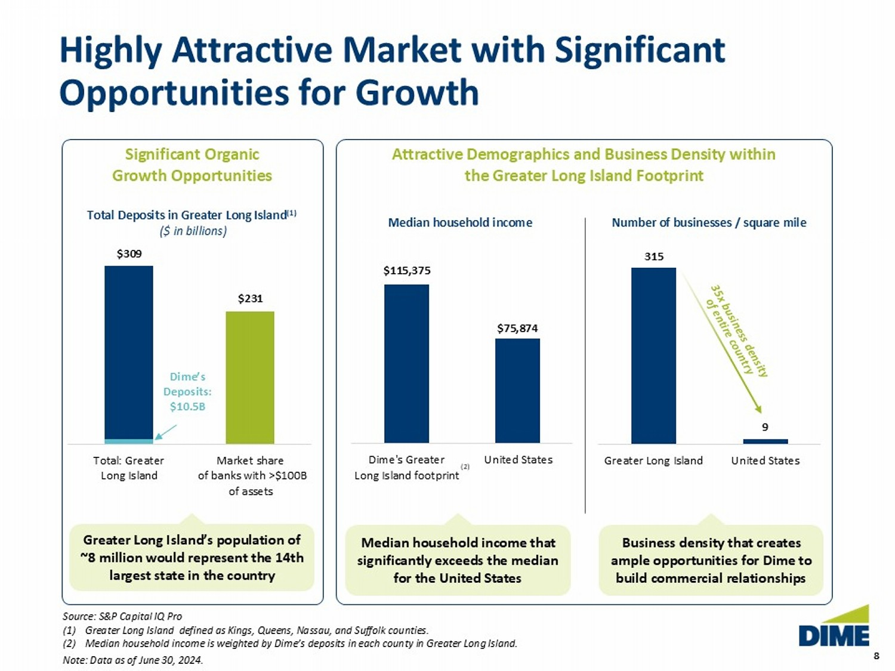
8 8 Highly Attractive Market with Significant Opportunities for Growth $309 $231 Total: Greater Long Island Market share of banks with >$100B of assets $115,375 $75,874 Dime's Greater Long Island footprint United States Total Deposits in Greater Long Island (1) ($ in billions) Median household income Number of businesses / square mile 315 9 Greater Long Island United States (2) Significant Organic Growth Opportunities Greater Long Island’s population of ~8 million would represent the 14th largest state in the country Attractive Demographics and Business Density within the Greater Long Island Footprint Dime’s Deposits: $10.5B Median household income that significantly exceeds the median for the United States Business density that creates ample opportunities for Dime to build commercial relationships Source: S&P Capital IQ Pro (1) Greater Long Island defined as Kings, Queens, Nassau, and Suffolk counties. (2) Median household income is weighted by Dime’s deposits in each county in Greater Long Island. Note: Data as of June 30, 2024.
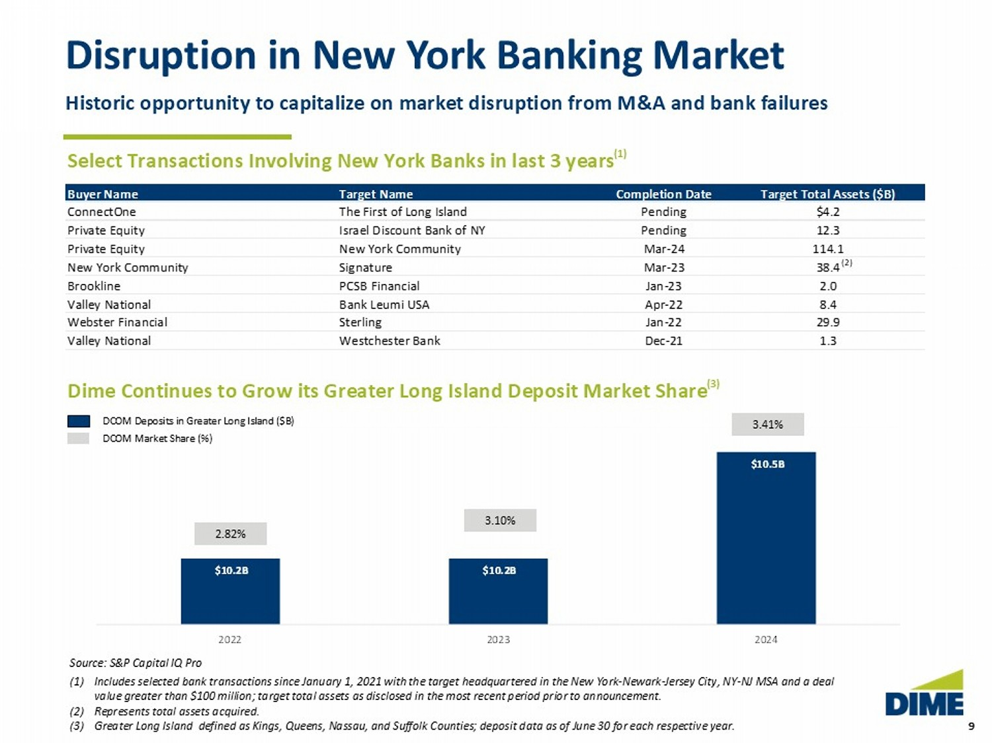
9 9 $10.2B $10.2B $10.5B 2022 2023 2024 2.82% 3.10% 3.41% Disruption in New York Banking Market Source: S&P Capital IQ Pro (1) Includes selected bank transactions since January 1, 2021 with the target headquartered in the New York - Newark - Jersey City, NY - N J MSA and a deal value greater than $100 million; target total assets as disclosed in the most recent period prior to announcement. (2) Represents total assets acquired. (3) Greater Long Island defined as Kings, Queens, Nassau, and Suffolk Counties; deposit data as of June 30 for each respective y ear . Select Transactions Involving New York Banks in last 3 years (1) Dime Continues to Grow its Greater Long Island Deposit Market Share (3) DCOM Deposits in Greater Long Island ($B) DCOM Market Share (%) (2) Historic opportunity to capitalize on market disruption from M&A and bank failures Buyer Name Target Name Completion Date Target Total Assets ($B) ConnectOne The First of Long Island Pending $4.2 Private Equity Israel Discount Bank of NY Pending 12.3 Private Equity New York Community Mar-24 114.1 New York Community Signature Mar-23 38.4 Brookline PCSB Financial Jan-23 2.0 Valley National Bank Leumi USA Apr-22 8.4 Webster Financial Sterling Jan-22 29.9 Valley National Westchester Bank Dec-21 1.3
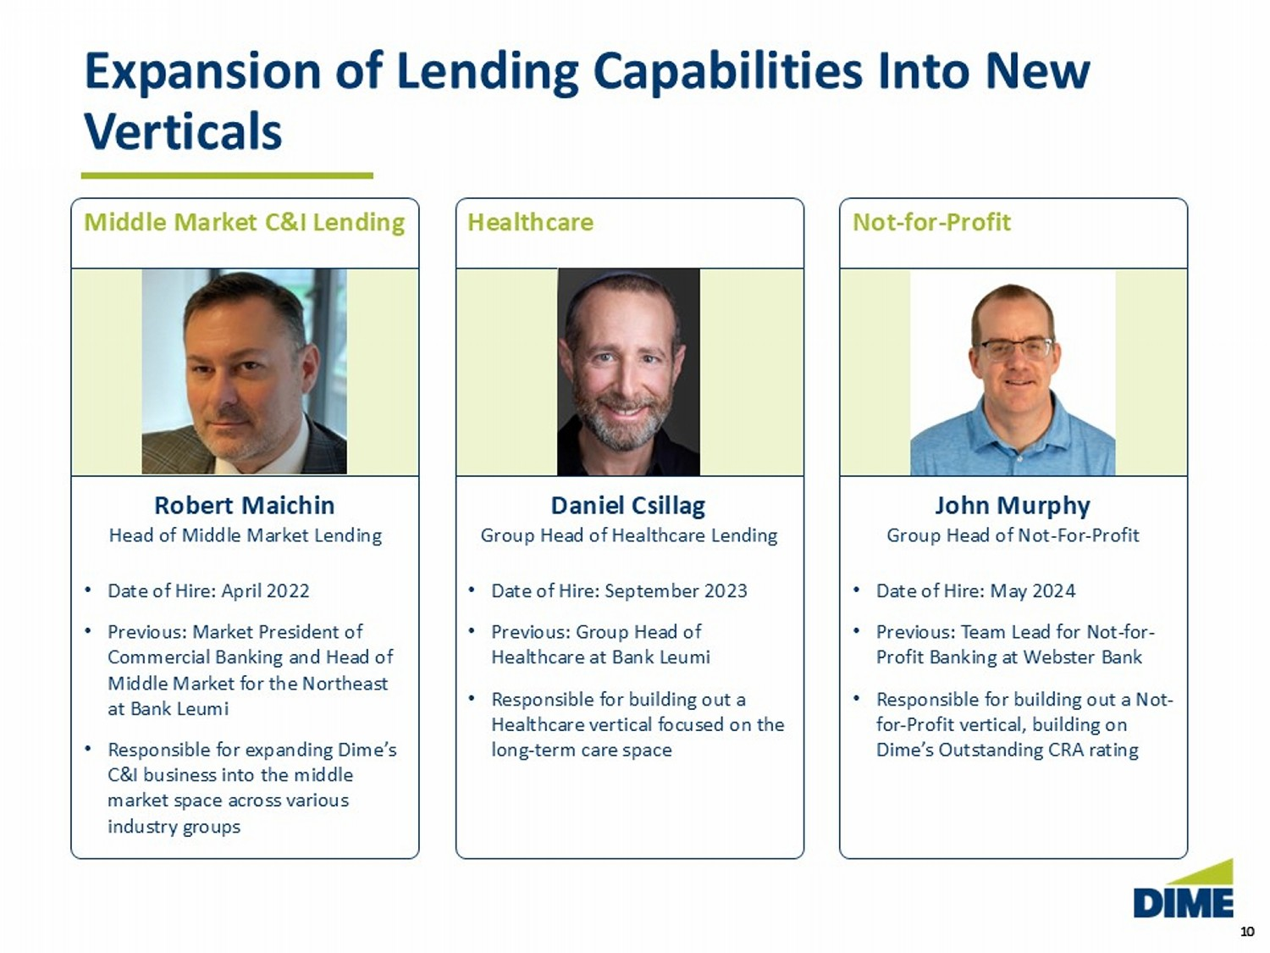
10 10 Middle Market C&I Lending Healthcare Not - for - Profit Expansion of Lending Capabilities Into New Verticals Robert Maichin Head of Middle Market Lending • Date of Hire: April 2022 • Previous: Market President of Commercial Banking and Head of Middle Market for the Northeast at Bank Leumi • Responsible for expanding Dime’s C&I business into the middle market space across various industry groups Daniel Csillag Group Head of Healthcare Lending • Date of Hire: September 2023 • Previous: Group Head of Healthcare at Bank Leumi • Responsible for building out a Healthcare vertical focused on the long - term care space John Murphy Group Head of Not - For - Profit • Date of Hire: May 2024 • Previous: Team Lead for Not - for - Profit Banking at Webster Bank • Responsible for building out a Not - for - Profit vertical, building on Dime’s Outstanding CRA rating
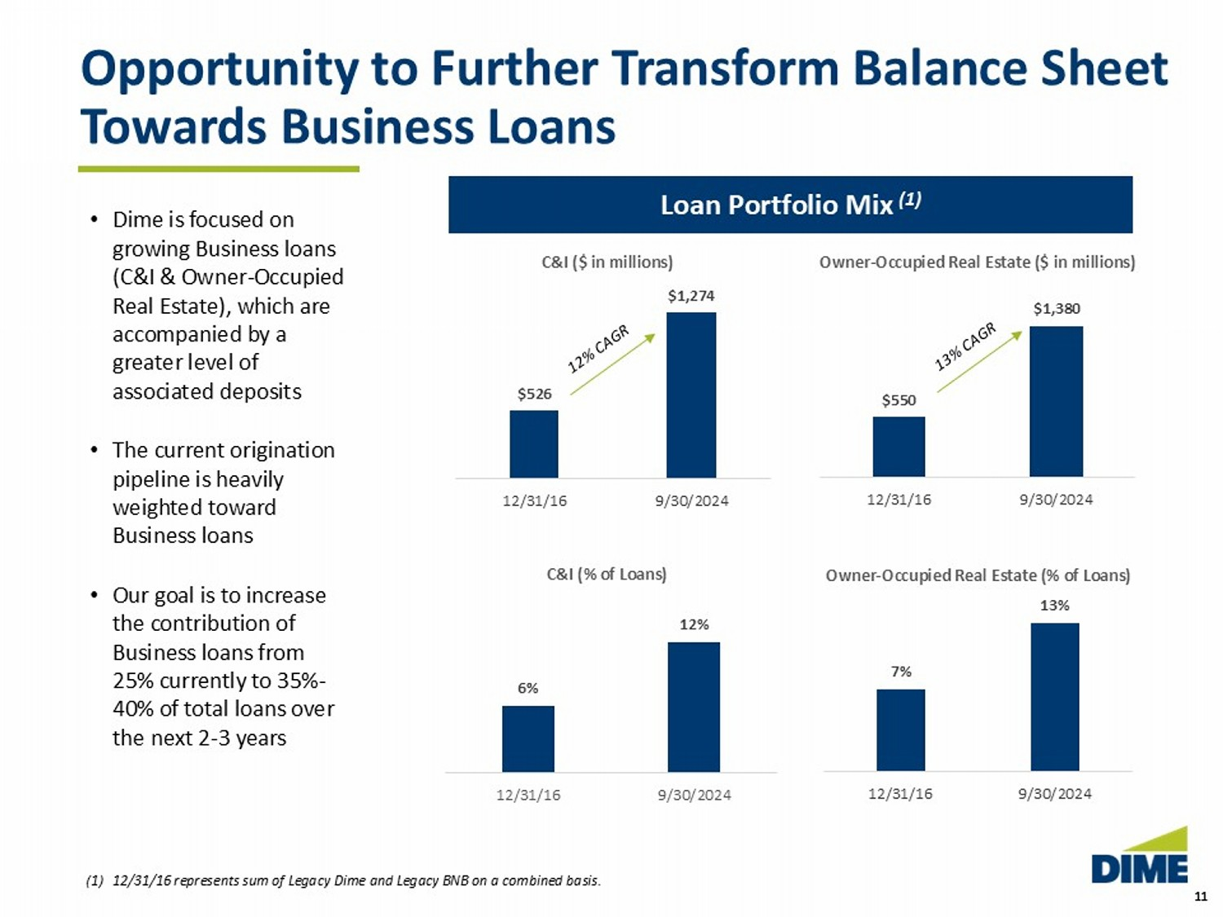
11 11 Opportunity to Further Transform Balance Sheet Towards Business Loans Loan Portfolio Mix (1) (1) 12/31/16 represents sum of Legacy Dime and Legacy BNB on a combined basis. $526 $1,274 12/31/16 9/30/2024 C&I ($ in millions) 6% 12% 12/31/16 9/30/2024 C&I (% of Loans) 7% 13% 12/31/16 9/30/2024 $550 $1,380 12/31/16 9/30/2024 • Dime is focused on growing Business loans (C&I & Owner - Occupied Real Estate), which are accompanied by a greater level of associated deposits • The current origination pipeline is heavily weighted toward Business loans • Our goal is to increase the contribution of Business loans from 25% currently to 35% - 40% of total loans over the next 2 - 3 years Owner - Occupied Real Estate (% of Loans) Owner - Occupied Real Estate ($ in millions)
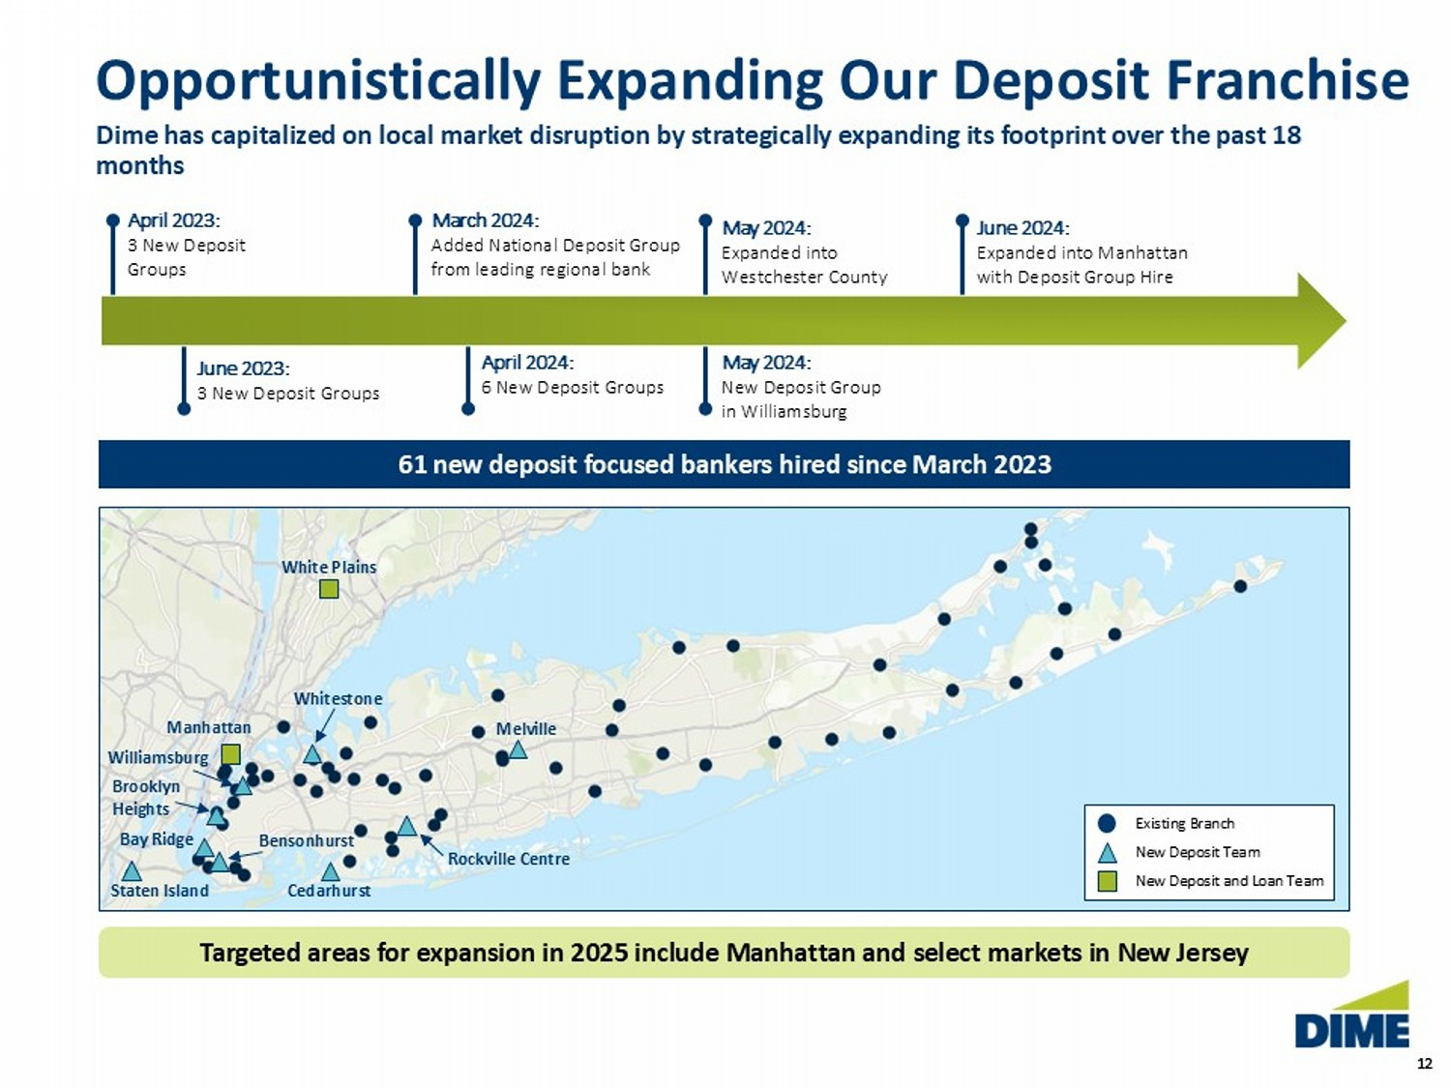
12 12 Opportunistically Expanding Our Deposit Franchise Dime has capitalized on local market disruption by strategically expanding its footprint over the past 18 months April 2023: 3 New Deposit Groups June 2023: 3 New Deposit Groups March 2024: Added National Deposit Group from leading regional bank April 2024: 6 New Deposit Groups May 2024: Expanded into Westchester County May 2024: New Deposit Group in Williamsburg June 2024: Expanded into Manhattan with Deposit Group Hire 61 new deposit focused bankers hired since March 2023 Williamsburg Manhattan Rockville Centre Whitestone Melville Staten Island Cedarhurst Brooklyn Heights Bay Ridge Bensonhurst White Plains Existing Branch New Deposit Team New Deposit and Loan Team Targeted areas for expansion in 2025 include Manhattan and select markets in New Jersey
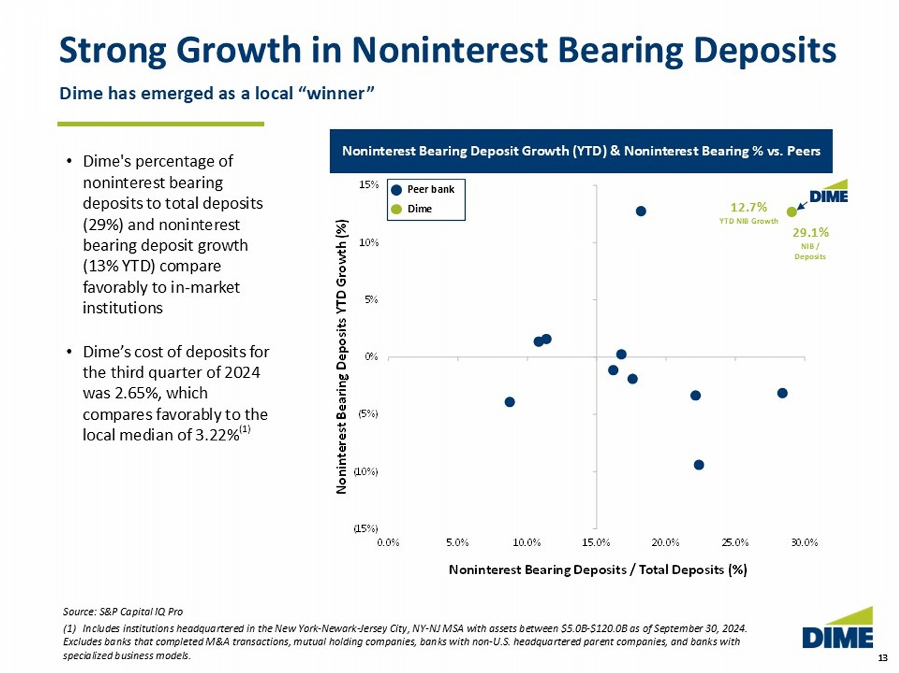
13 13 (15%) (10%) (5%) 0% 5% 10% 15% 0.0% 5.0% 10.0% 15.0% 20.0% 25.0% 30.0% Noninterest Bearing Deposits YTD Growth (%) Noninterest Bearing Deposits / Total Deposits (%) Strong Growth in Noninterest Bearing Deposits Source: S&P Capital IQ Pro (1) Includes institutions headquartered in the New York - Newark - Jersey City, NY - NJ MSA with assets between $5.0B - $120.0B as of September 30, 2024. Excludes banks that completed M&A transactions, mutual holding companies, banks with non - U.S. headquartered parent companies, an d banks with specialized business models. Noninterest Bearing Deposit Growth (YTD) & Noninterest Bearing % vs. Peers • Dime's percentage of noninterest bearing deposits to total deposits (29%) and noninterest bearing deposit growth (13% YTD) compare favorably to in - market institutions • Dime’s cost of deposits for the third quarter of 2024 was 2.65%, which compares favorably to the local median of 3.22% (1) Dime has emerged as a local “winner” 12.7% YTD NIB Growth 29.1% NIB / Deposits Peer bank Dime
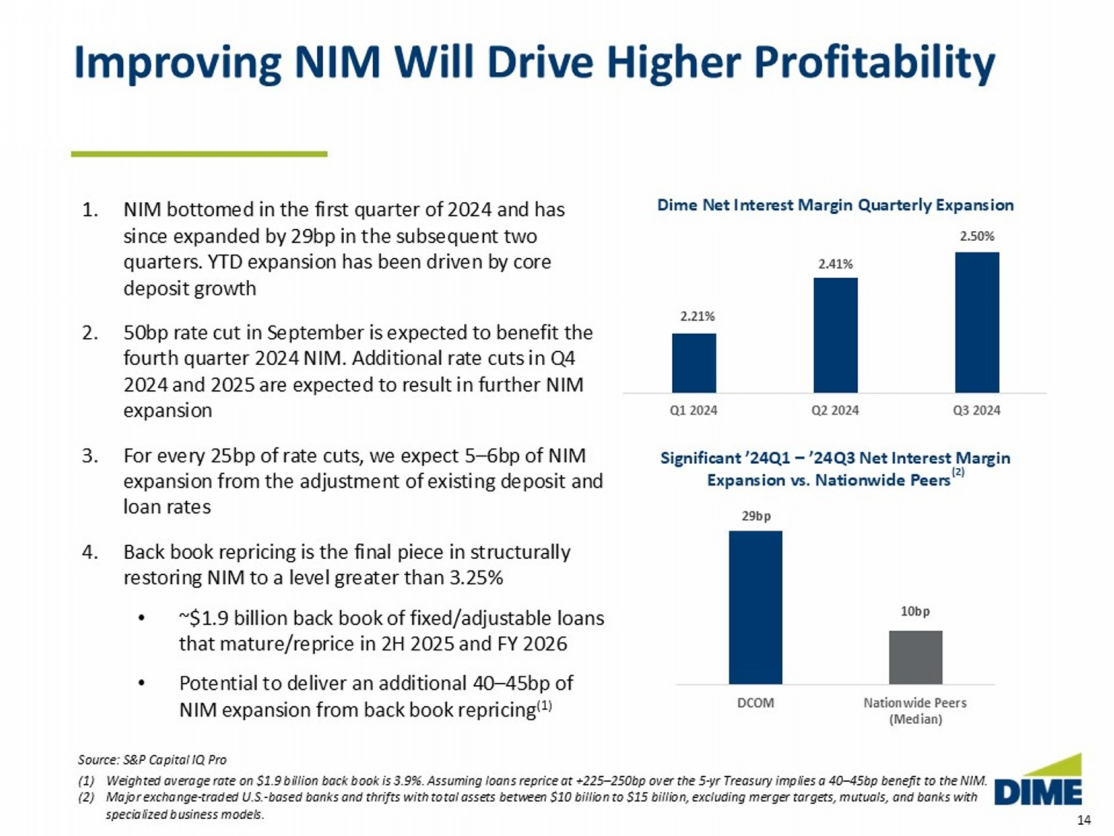
14 14 29bp 10bp DCOM Nationwide Peers (Median) Significant ’24Q1 – ’24Q3 Net Interest Margin Expansion vs. Nationwide Peers (2) Improving NIM Will Drive Higher Profitability 1. NIM bottomed in the first quarter of 2024 and has since expanded by 29bp in the subsequent two quarters. YTD expansion has been driven by core deposit growth 2. 50bp rate cut in September is expected to benefit the fourth quarter 2024 NIM. Additional rate cuts in Q4 2024 and 2025 are expected to result in further NIM expansion 3. For every 25bp of rate cuts, we expect 5 – 6bp of NIM expansion from the adjustment of existing deposit and loan rates 4. Back book repricing is the final piece in structurally restoring NIM to a level greater than 3.25% • ~$1.9 billion of fixed/adjustable loans that mature/reprice in 2H 2025 and FY 2026 • Potential to deliver an additional 40 – 45bp of NIM expansion from back book repricing (1) 2.21% 2.41% 2.50% Q1 2024 Q2 2024 Q3 2024 Dime Net Interest Margin Quarterly Expansion Source: S&P Capital IQ Pro (1) Weighted average rate on $1.9 billion back book is 3.9%. Assuming loans reprice at +225 – 250bp over the 5 - yr Treasury implies a 4 0 – 45bp benefit to the NIM. (2) Major exchange - traded U.S. - based banks and thrifts with total assets between $10 billion to $15 billion, excluding merger target s, mutuals, and banks with specialized business models.
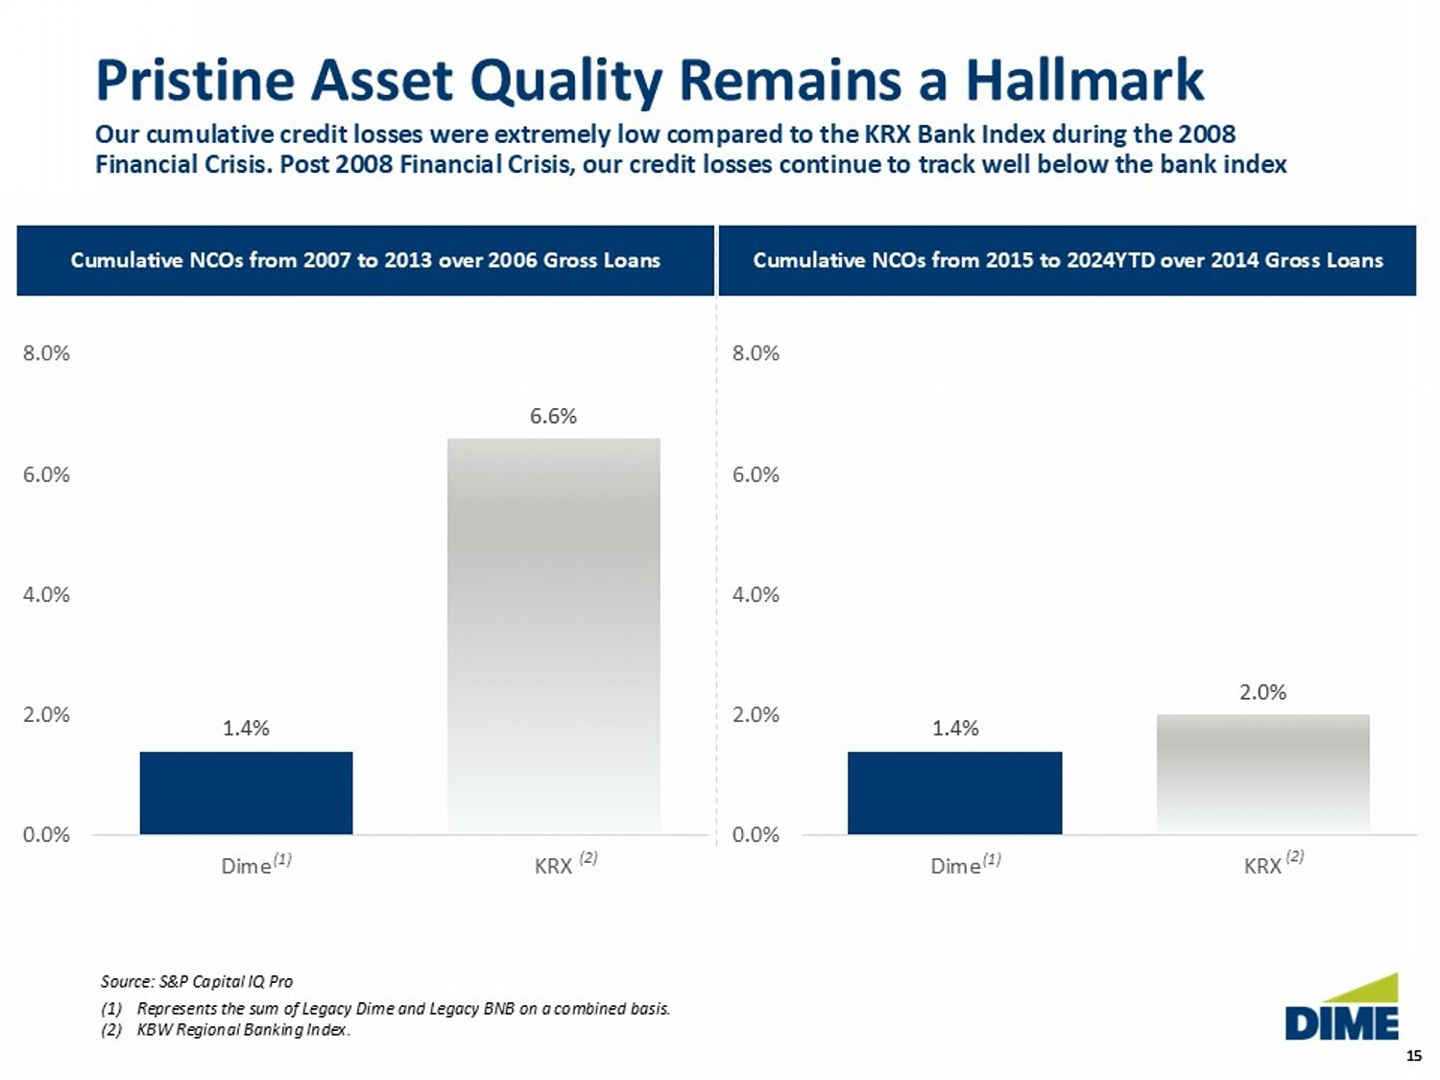
15 15 Pristine Asset Quality Remains a Hallmark Our cumulative credit losses were extremely low compared to the KRX Bank Index during the 2008 Financial Crisis. Post 2008 Financial Crisis, our credit losses continue to track well below the bank index Source: S&P Capital IQ Pro (1) Represents the sum of Legacy Dime and Legacy BNB on a combined basis. (2) KBW Regional Banking Index. Cumulative NCOs from 2007 to 2013 over 2006 Gross Loans Cumulative NCOs from 2015 to 2024YTD over 2014 Gross Loans 1.4% 6.6% 0.0% 2.0% 4.0% 6.0% 8.0% Dime KRX (1) (2) 1.4% 2.0% 0.0% 2.0% 4.0% 6.0% 8.0% Dime KRX (1) (2)
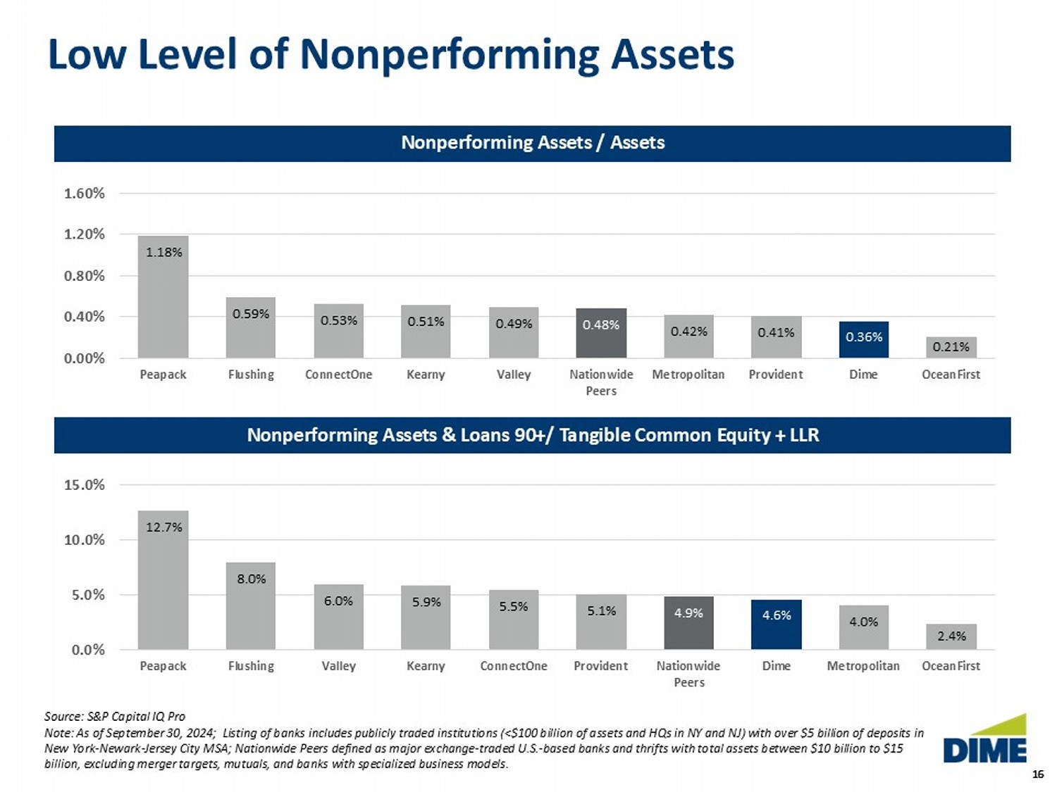
16 16 Low Level of Nonperforming Assets Source: S&P Capital IQ Pro Note: As of September 30, 2024; Listing of banks includes publicly traded institutions (<$100 billion of assets and HQs in N Y a nd NJ) with over $5 billion of deposits in New York - Newark - Jersey City MSA; Nationwide Peers defined as major exchange - traded U.S. - based banks and thrifts with total asset s between $10 billion to $15 billion, excluding merger targets, mutuals, and banks with specialized business models. Nonperform ing Assets / Assets 1.18% 0.59% 0.53% 0.51% 0.49% 0.48% 0.42% 0.41% 0.36% 0.21% 0.00% 0.40% 0.80% 1.20% 1.60% Peapack Flushing ConnectOne Kearny Valley Nationwide Peers Metropolitan Provident Dime OceanFirst Nonperforming Assets & Loans 90+/ Tangible Common Equity + LLR 12.7% 8.0% 6.0% 5.9% 5.5% 5.1% 4.9% 4.6% 4.0% 2.4% 0.0% 5.0% 10.0% 15.0% Peapack Flushing Valley Kearny ConnectOne Provident Nationwide Peers Dime Metropolitan OceanFirst
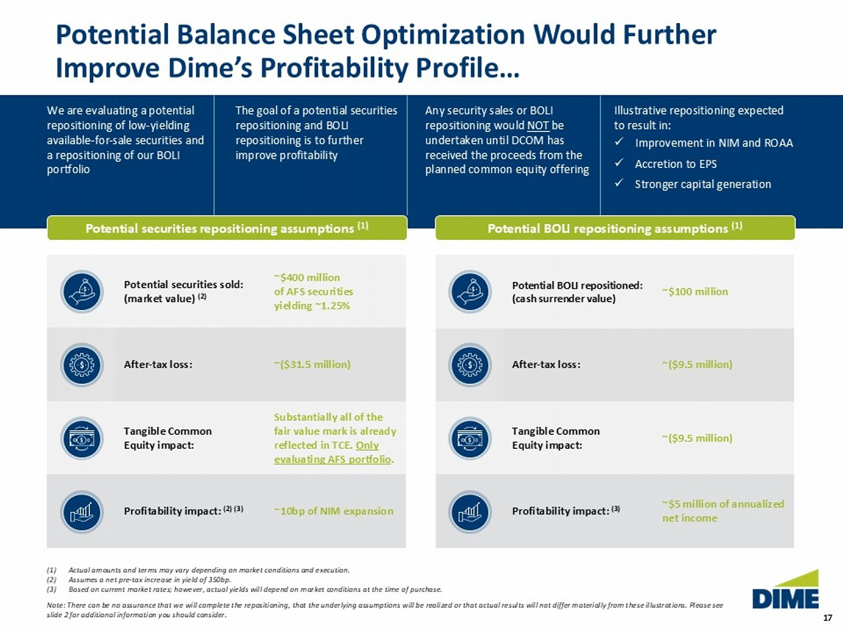
17 17 Potential Balance Sheet Optimization Would Further Improve Dime’s Profitability Profile… We are evaluating a potential repositioning of low - yielding available - for - sale securities and a repositioning of our BOLI portfolio The goal of a potential securities repositioning and BOLI repositioning is to further improve profitability Any security sales or BOLI repositioning would NOT be undertaken until DCOM has received the proceeds from the planned common equity offering Illustrative repositioning expected to result in: x Improvement in NIM and ROAA x Accretion to EPS x Stronger capital generation Potential securities repositioning assumptions (1) Potential BOLI repositioning assumptions (1) ~$400 million of AFS securities yielding ~1.25% Potential securities sold: (market value) (2) ~($31.5 million) After - tax loss: Substantially all of the fair value mark is already reflected in TCE. Only evaluating AFS portfolio . Tangible Common Equity impact: ~10bp of NIM expansion Profitability impact: (2) (3) (1) Actual amounts and terms may vary depending on market conditions and execution. (2) Assumes a net pre - tax increase in yield of 350bp. (3) Based on current market rates; however, actual yields will depend on market conditions at the time of purchase. Note: There can be no assurance that we will complete the repositioning, that the underlying assumptions will be realized or tha t actual results will not differ materially from these illustrations. Please see slide 2 for additional information you should consider. ~$100 million Potential BOLI repositioned: (cash surrender value) ~($9.5 million) After - tax loss: ~($9.5 million) Tangible Common Equity impact: ~$5 million of annualized net income Profitability impact: (3)
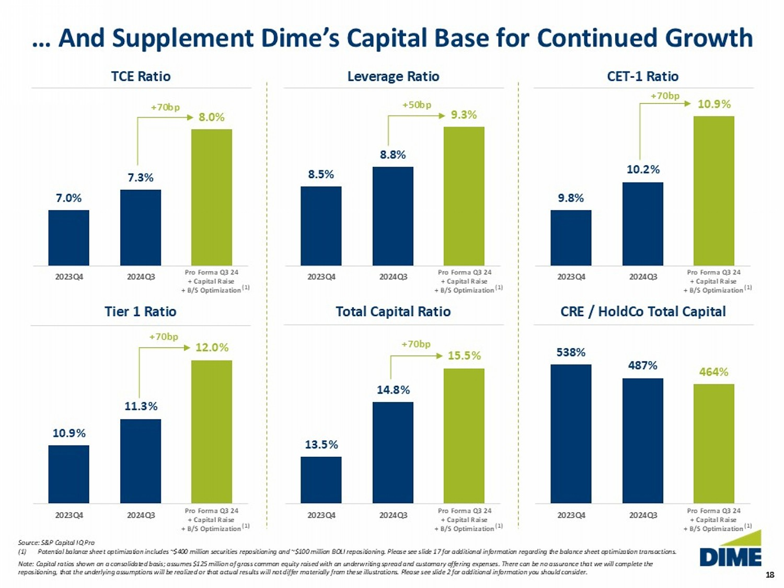
18 18 TCE Ratio 7.0% 7.3% 8.0% 2023Q4 2024Q3 – … And Supplement Dime’s Capital Base for Continued Growth Source: S&P Capital IQ Pro (1) Potential b alance shee t optimization includes ~$400 million securities repositioning and ~$100 million BOLI repositioning. Please see slide 17 for additional information regarding the balance sheet optimization transactions. Note: Capital ratios shown on a consolidated basis; assumes $125 million of gross common equity raised with an underwriting s pre ad and customary offering expenses. There can be no assurance that we will complete the repositioning, that the underlying assumptions will be realized or that actual results will not differ materially from these ill ustrations. Please see slide 2 for additional information you should consider. CET - 1 Ratio 9.8% 10.2% 10.9% 2023Q4 2024Q3 – Tier 1 Ratio Total Capital Ratio Leverage Ratio 10.9% 11.3% 12.0% 2023Q4 2024Q3 – 13.5% 14.8% 15.5% 2023Q4 2024Q3 – 8.5% 8.8% 9.3% 2023Q4 2024Q3 – CRE / HoldCo Total Capital 538% 487% 464% 2023Q4 2024Q3 – +70bp Pro Forma Q3 24 + Capital Raise + B/S Optimization Pro Forma Q3 24 + Capital Raise + B/S Optimization Pro Forma Q3 24 + Capital Raise + B/S Optimization Pro Forma Q3 24 + Capital Raise + B/S Optimization Pro Forma Q3 24 + Capital Raise + B/S Optimization Pro Forma Q3 24 + Capital Raise + B/S Optimization + 7 0bp + 7 0bp + 7 0bp +50bp (1) (1) (1) (1) (1) (1)
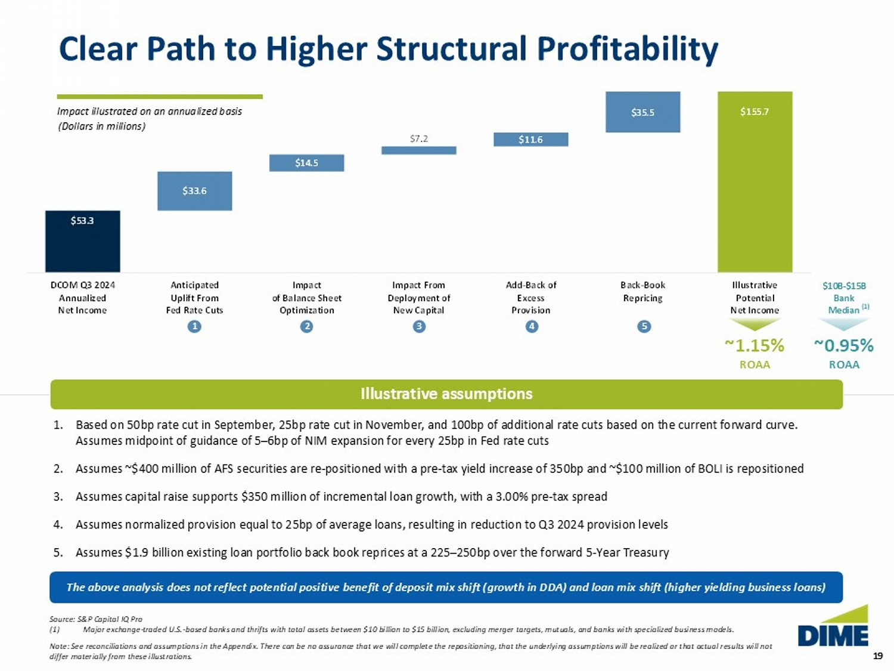
19 19 $10B - $15B Bank Median $53.3 $108.6 $155.7 $33.6 $14.5 $7.2 $11.6 $35.5 DCOM Q3 2024 Annualized Net Income Anticipated Uplift From Fed Rate Cuts Impact of Balance Sheet Optimization Impact From Deployment of New Capital Add-Back of Excess Provision Back-Book Repricing Illustrative Potential Net Income Clear Path to Higher Structural Profitability ~1.15% ROAA Illustrative assumptions 1. Based on 50bp rate cut in September, 25bp rate cut in November, and 100bp of additional rate cuts based on the current forwar d c urve. Assumes midpoint of guidance of 5 – 6bp of NIM expansion for every 25bp in Fed rate cuts 2. Assumes ~$400 million of AFS securities are re - positioned with a pre - tax yield increase of 350bp and ~$100 million of BOLI is re positioned 3. Assumes capital raise supports $350 million of incremental loan growth, with a 3.00% pre - tax spread 4. Assumes normalized provision equal to 25bp of average loans, resulting in reduction to Q3 2024 provision levels 5. Assumes $1.9 billion existing loan portfolio back book reprices at a 225 – 250bp over the forward 5 - Year Treasury Source: S&P Capital IQ Pro (1) Major exchange - traded U.S. - based banks and thrifts with total assets between $10 billion to $15 billion, excluding merger target s, mutuals, and banks with specialized business models. Note: See reconciliations and assumptions in the Appendix. There can be no assurance that we will complete the repositioning, th at the underlying assumptions will be realized or that actual results will not differ materially from these illustrations. Impact illustrated on an annualized basis (1 ) ~0.95% ROAA (Dollars in millions) 1 2 3 4 5 The above analysis does not reflect potential positive benefit of deposit mix shift (growth in DDA) and loan mix shift (highe r y ielding business loans)
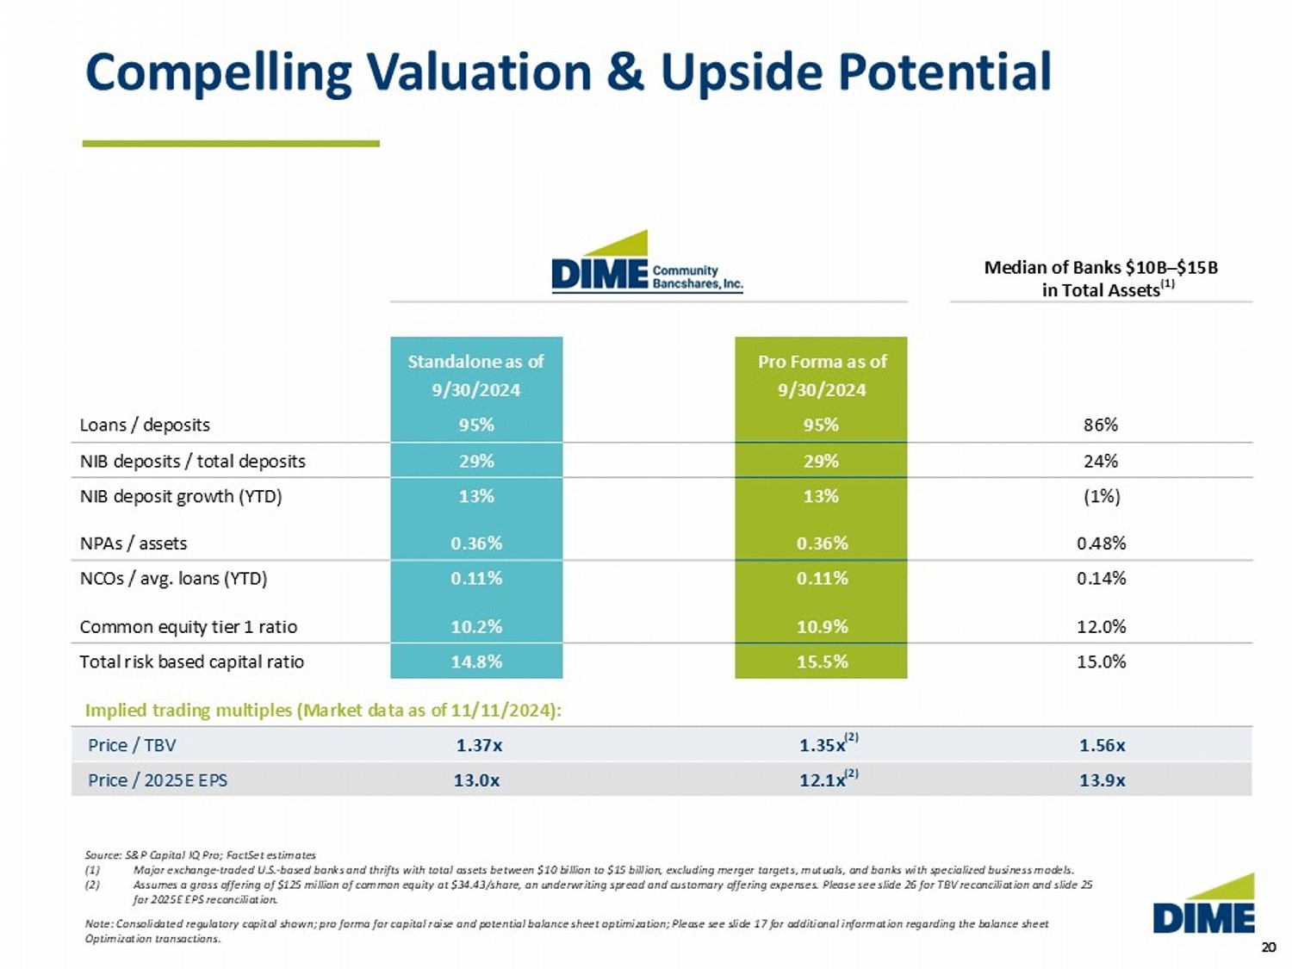
20 20 Compelling Valuation & Upside Potential Source: S&P Capital IQ Pro; FactSet estimates (1) Major exchange - traded U.S. - based banks and thrifts with total assets between $10 billion to $15 billion, excluding merger target s, mutuals, and banks with specialized business models. (2) Assumes a gross offering of $12 5 million of common equity at $34.43/share, an underwriting spread and customary offering expenses. Please see slide 26 for TBV reconciliation and slide 25 for 2025E EPS reconciliation. Note: Consolidated regulatory capital shown; pro forma for capital raise and potential balance sheet optimization; Please see slide 17 for additional information regarding the balance sheet Optimization transactions. Median of Banks $10B – $15B in Total Assets Pro Forma as of Standalone as of 9/30/2024 9/30/2024 86% 95% 95% Loans / deposits 24% 29% 29% NIB deposits / total deposits (1%) 13% 13% NIB deposit growth (YTD) 0.48% 0.36% 0.36% NPAs / assets 0.14% 0.11% 0.11% NCOs / avg. loans (YTD) 12.0% 10.9% 10.2% Common equity tier 1 ratio 15.0% 15.5% 14.8% Total risk based capital ratio Implied trading multiples (Market data as of 11/11/2024): 1.56x 1.35x 1.37x Price / TBV 13.9x 12.1x 13.0x Price / 2025E EPS (2) (2) (1)
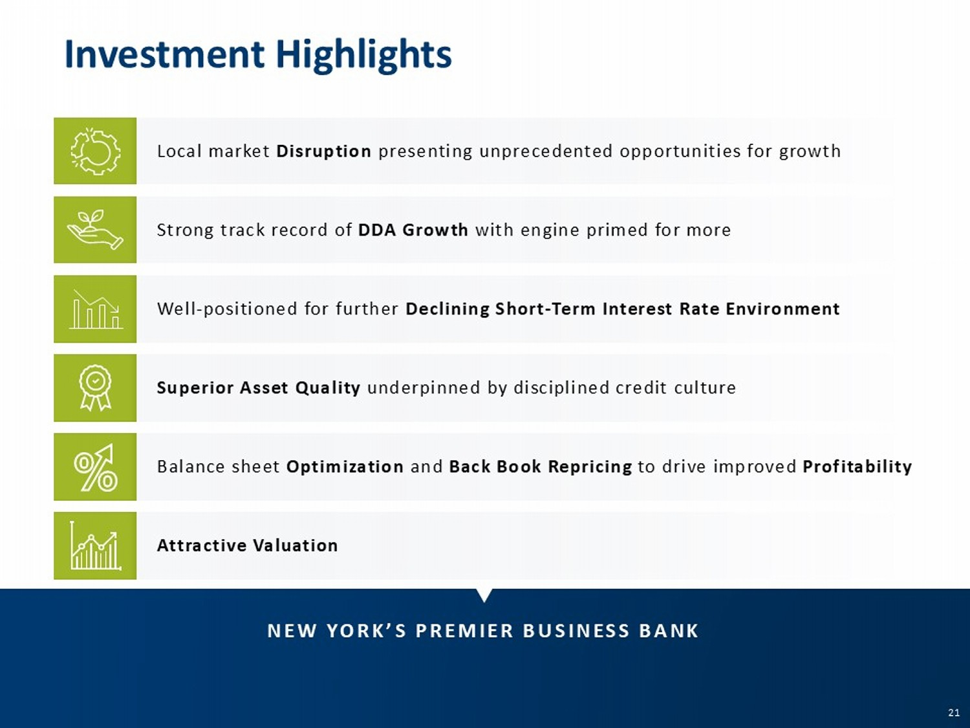
21 21 Local market Disruption presenting unprecedented opportunities for growth Strong track record of DDA Growth with engine primed for more Well - positioned for further Declining Short - Term Interest Rate Environment Superior Asset Quality underpinned by disciplined credit culture 21 NEW YORK’S PREMIER BUSINESS BANK Investment Highlights Attractive Valuation Balance sheet Optimization and Back Book Repricing to drive improved Profitability
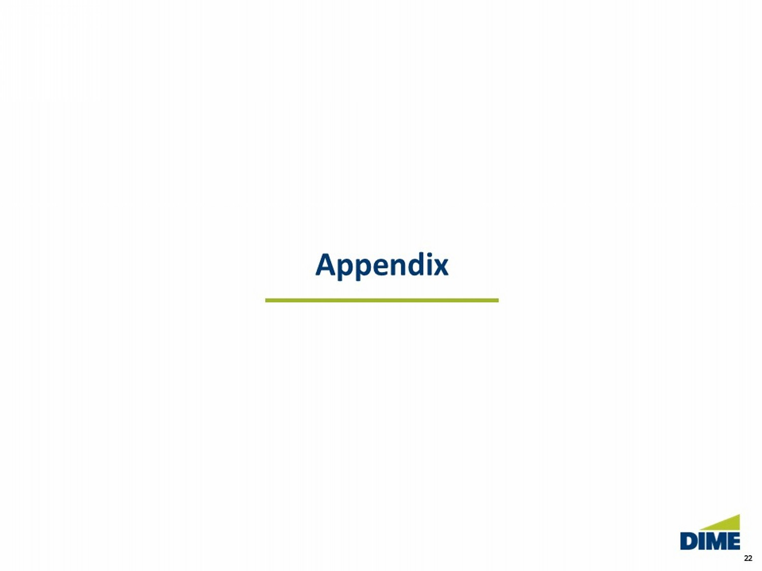
22 22 Appendix
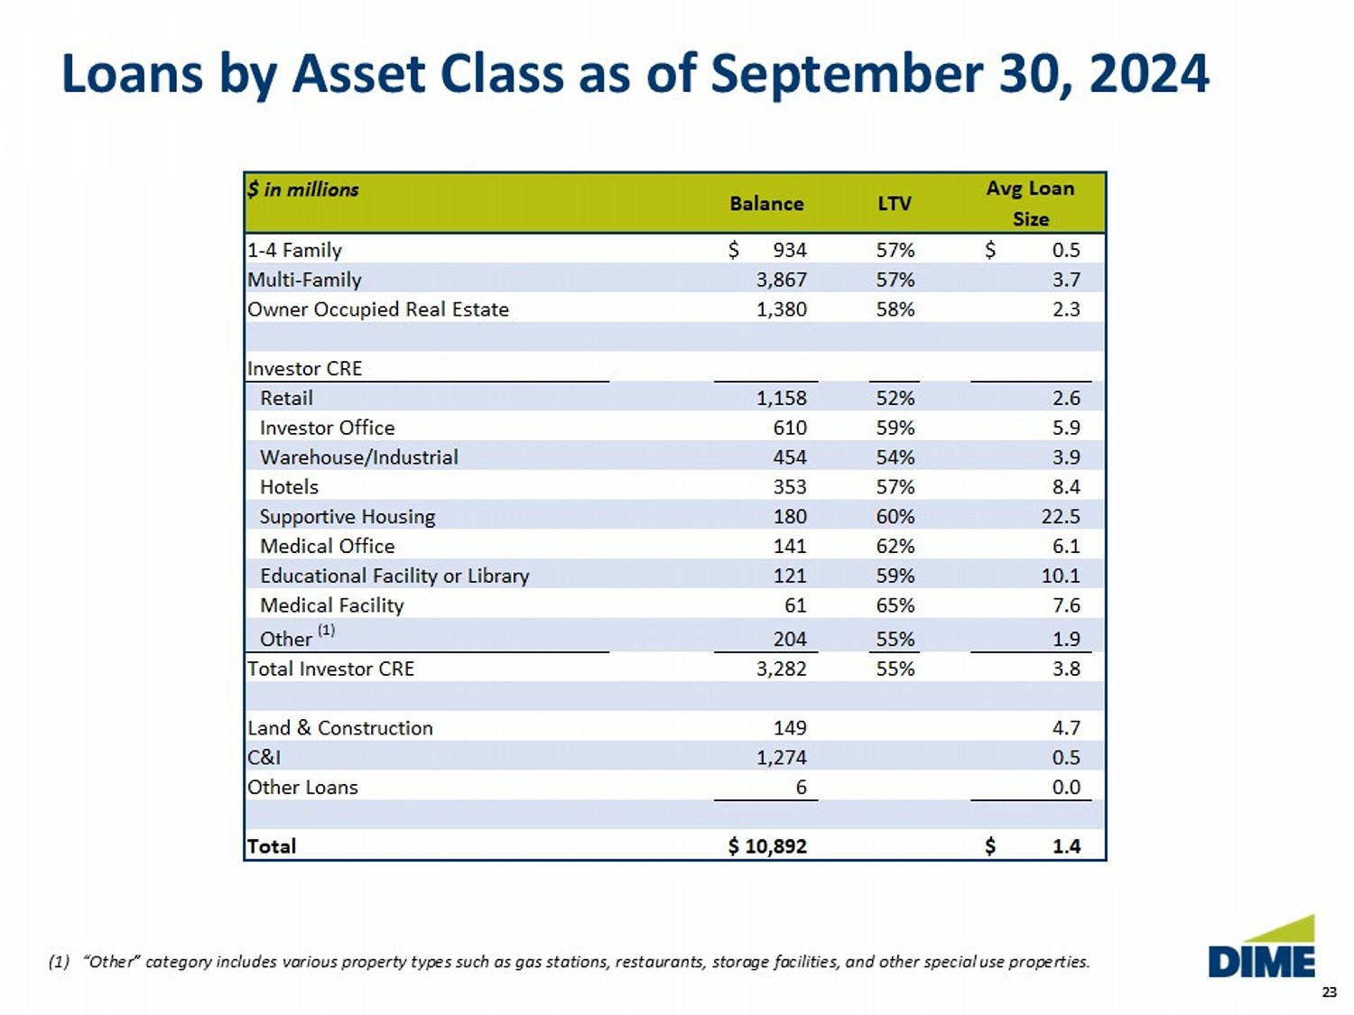
23 23 $ in millions Avg Loan Size 1-4 Family 934$ 57% 0.5$ Multi-Family 3,867 57% 3.7 Owner Occupied Real Estate 1,380 58% 2.3 Investor CRE Retail 1,158 52% 2.6 Investor Office 610 59% 5.9 Warehouse/Industrial 454 54% 3.9 Hotels 353 57% 8.4 Supportive Housing 180 60% 22.5 Medical Office 141 62% 6.1 Educational Facility or Library 121 59% 10.1 Medical Facility 61 65% 7.6 Other (1) 204 55% 1.9 Total Investor CRE 3,282 55% 3.8 Land & Construction 149 4.7 C&I 1,274 0.5 Other Loans 6 0.0 Total 10,892$ 1.4$ Balance LTV Loans by Asset Class as of September 30, 2024 (1) “Other” category includes various property types such as gas stations, restaurants, storage facilities, and other speci al use properties.
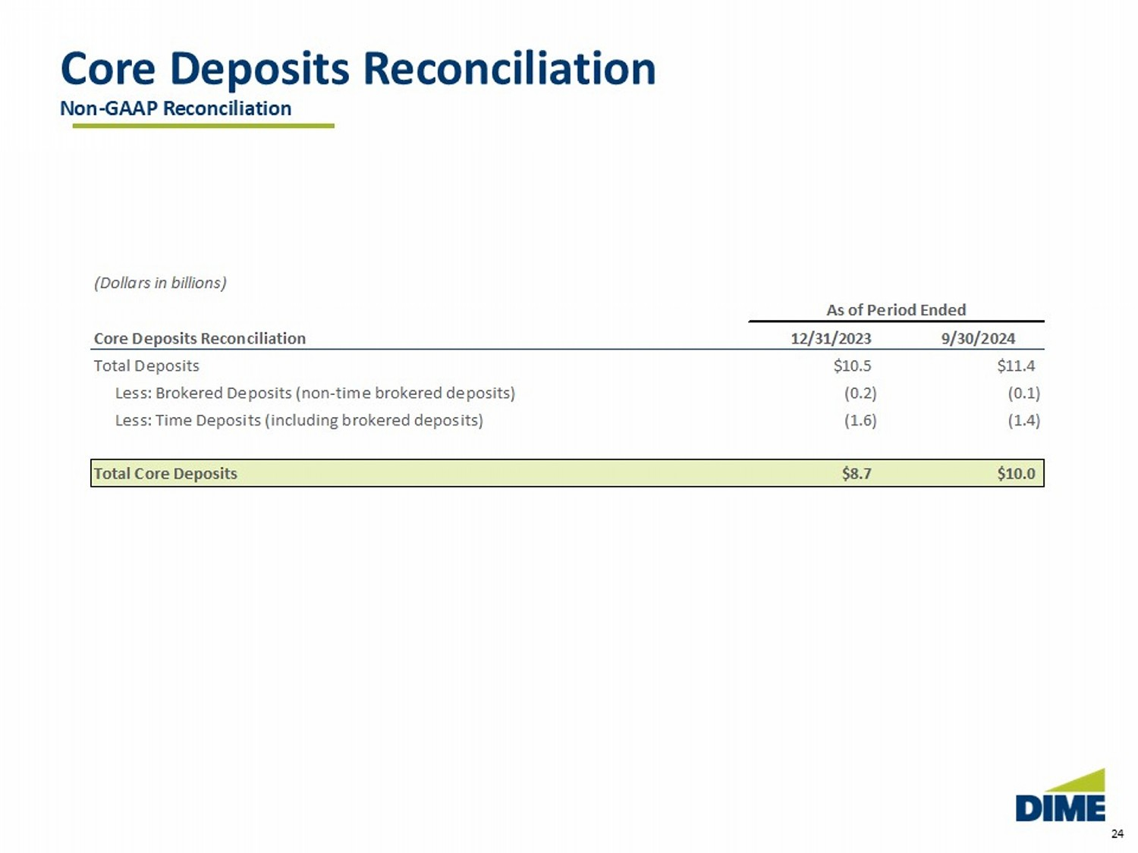
24 Core Deposits Reconciliation Non - GAAP Reconciliation (Dollars in billions) As of Period Ended Core Deposits Reconciliation 12/31/2023 9/30/2024 Total Deposits $10.5 $11.4 Less: Brokered Deposits (non-time brokered deposits) (0.2) (0.1) Less: Time Deposits (including brokered deposits) (1.6) (1.4) Total Core Deposits $8.7 $10.0
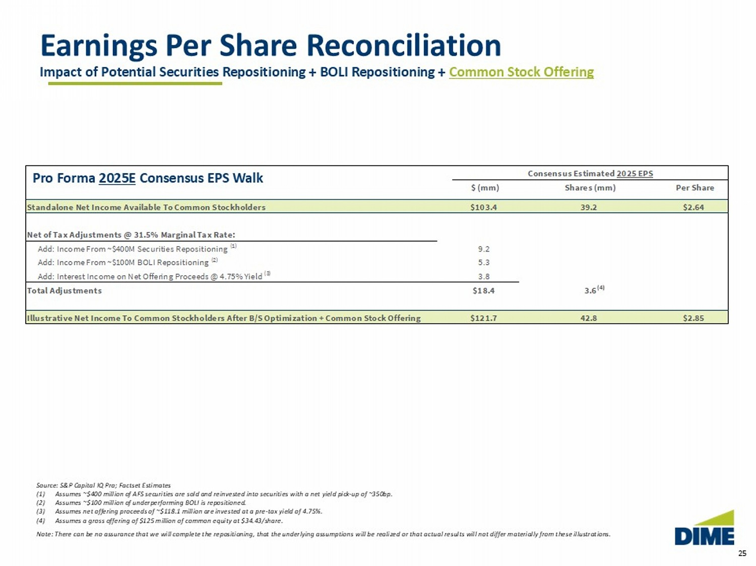
25 Consensus Estimated 2025 EPS $ (mm) Shares (mm) Per Share Standalone Net Income Available To Common Stockholders $103.4 39.2 $2.64 Net of Tax Adjustments @ 31.5% Marginal Tax Rate: Add: Income From ~$400M Securities Repositioning (1) 9.2 Add: Income From ~$100M BOLI Repositioning (2) 5.3 Add: Interest Income on Net Offering Proceeds @ 4.75% Yield (3) 3.8 Total Adjustments $18.4 3.6 Illustrative Net Income To Common Stockholders After B/S Optimization + Common Stock Offering $121.7 42.8 $2.85 Earnings Per Share Reconciliation Impact of Potential Securities Repositioning + BOLI Repositioning + Common Stock Offering Source: S&P Capital IQ Pro; Factset Estimates (1) Assumes ~$400 million of AFS securities are sold and reinvested into securities with a net yield pick - up of ~350bp. (2) Assumes ~$100 million of underperforming BOLI is repositioned. (3) Assumes net offering proceeds of ~$118.1 million are invested at a pre - tax yield of 4.75%. (4) Assumes a gross offering of $125 million of common equity at $34.43/share. Note: There can be no assurance that we will complete the repositioning, that the underlying assumptions will be realized or tha t actual results will not differ materially from these illustrations. (4) Pro Forma 2025E Consensus EPS Walk
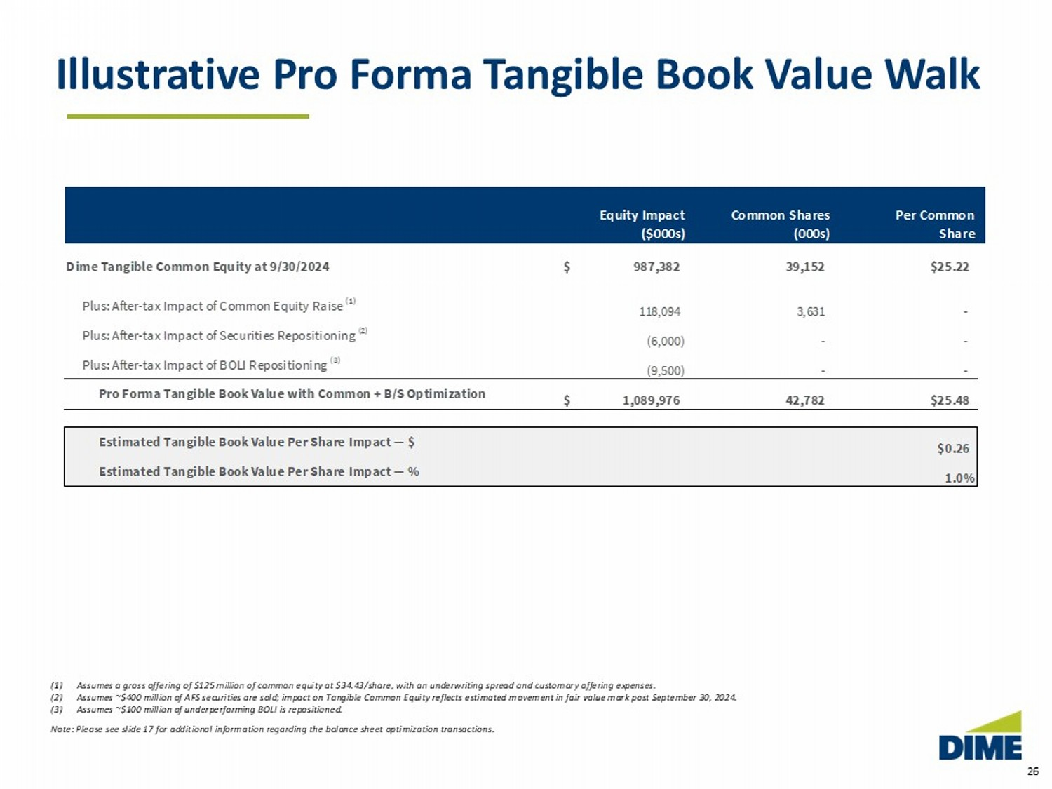
26 Illustrative Pro Forma Tangible Book Value Walk (1) Assumes a gross offering of $125 million of common equity at $34.43/share, with an underwriting spread and customary offering ex penses. (2) Assumes ~$400 million of AFS securities are sold ; impact on Tangible Common Equity reflects estimated movement in fair value mark post September 30, 2024 . (3) Assumes ~$100 million of underperforming BOLI is repositioned. Note: Please see slide 17 for additional information regarding the balance sheet optimization transactions. Equity Impact Common Shares Per Common ($000s) (000s) Share Dime Tangible Common Equity at 9/30/2024 987,382$ 39,152 $25.22 Plus: After-tax Impact of Common Equity Raise (1) 118,094 3,631 - Plus: After-tax Impact of Securities Repositioning (2) (6,000) - - Plus: After-tax Impact of BOLI Repositioning (3) (9,500) - - Pro Forma Tangible Book Value with Common + B/S Optimization 1,089,976$ 42,782 $25.48 Estimated Tangible Book Value Per Share Impact — $ $0.26 Estimated Tangible Book Value Per Share Impact — % 1.0%
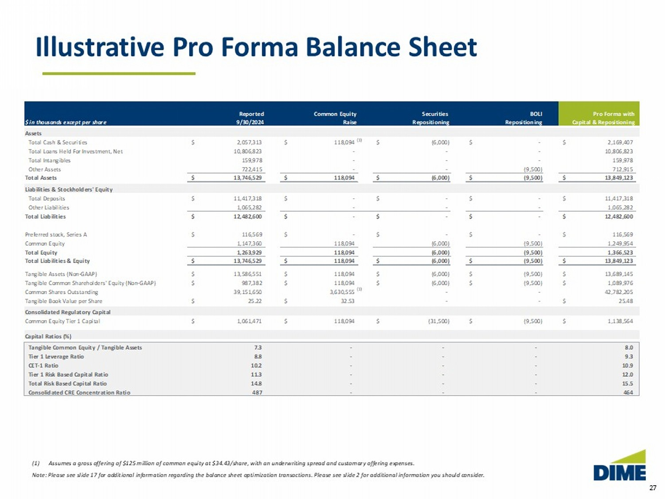
27 Illustrative Pro Forma Balance Sheet (1) Assumes a gross offering of $125 million of common equity at $34.43/share, with an underwriting spread and customary offering ex penses. Note: Please see slide 17 for additional information regarding the balance sheet optimization transactions. Please see slide 2 f or additional information you should consider. Reported Common Equity Securities BOLI Pro Forma with $ in thousands except per share 9/30/2024 Raise Repositioning Repositioning Capital & Repositioning Assets Total Cash & Securities 2,057,313$ 118,094$ (6,000)$ -$ 2,169,407$ Total Loans Held For Investment, Net 10,806,823 - - - 10,806,823 Total Intangibles 159,978 - - - 159,978 Other Assets 722,415 - - (9,500) 712,915 Total Assets 13,746,529$ 118,094$ (6,000)$ (9,500)$ 13,849,123$ Liabilities & Stockholders' Equity Total Deposits 11,417,318$ -$ -$ -$ 11,417,318$ Other Liabilities 1,065,282 - - - 1,065,282 Total Liabilities 12,482,600$ -$ -$ -$ 12,482,600$ Preferred stock, Series A 116,569$ -$ -$ -$ 116,569$ Common Equity 1,147,360 118,094 (6,000) (9,500) 1,249,954 Total Equity 1,263,929 118,094 (6,000) (9,500) 1,366,523 Total Liabilities & Equity 13,746,529$ 118,094$ (6,000)$ (9,500)$ 13,849,123$ Tangible Assets (Non-GAAP) 13,586,551$ 118,094$ (6,000)$ (9,500)$ 13,689,145$ Tangible Common Shareholders' Equity (Non-GAAP) 987,382$ 118,094$ (6,000)$ (9,500)$ 1,089,976$ Common Shares Outstanding 39,151,650 3,630,555 - - 42,782,205 Tangible Book Value per Share 25.22$ 32.53$ - - 25.48$ Consolidated Regulatory Capital Common Equity Tier 1 Capital 1,061,471$ 118,094$ (31,500)$ (9,500)$ 1,138,564$ Capital Ratios (%) Tangible Common Equity / Tangible Assets 7.3 - - - 8.0 Tier 1 Leverage Ratio 8.8 - - - 9.3 CET-1 Ratio 10.2 - - - 10.9 Tier 1 Risk Based Capital Ratio 11.3 - - - 12.0 Total Risk Based Capital Ratio 14.8 - - - 15.5 Consolidated CRE Concentration Ratio 487 - - - 464 (1) (1)

